**Advances in Data Science**

**Final Project**

**GEOSPATIAL ANALYSIS - PROPERTY RATE PREDICTION**

Karan Thever

Pratik Patre

Rahul Chandra

**Overview:**

The rate of a property depends on factors like the total area, type of property or how much is the development in the area. But, there are other aspect to this as well i.e. spatial components. Spatial components can be one of the most important factors in determining the price of a location. Some of these components include the fatality rate due to natural calamities, the crime rates or number of hospitals, police and other facilities like these in an area. These factors do play an important role for finding an appropriate Property Rate.

The Datasets that were used in our project were as follows:

1. Crime Data
2. Police Data
3. Property Data
4. Tragedy Data
5. Population Data
6. Hospital Data

The goal of this project is to cover the following Use Cases:

1. To show a User 5 probable property listings as per his input values.
2. To predict the prices of these property listings after 10 years as per the historical data of the property.
3. To predict the property price after 10 years per geospatial data.
4. To find out the current property rate for State of Texas based on above all parameters.

Key Concepts which we covered while working on ArcMAP:

1. Adding new Map and adding appropriate properties for a project
2. Creating Layers from different map
3. Associate data to maps and create appropriate symbology
4. Creating Feature Classes.
5. Geoprocessing
6. Geospatial Analysis

**Data:**

The first challenge was to retrieve all these data as per latitude and longitude so that it can be mapped easily on ArcMAP. It was difficult to find such data and retrieve it. After extensive exploration, we could find shape files for some data and for other data we had to run R code to get data in proper format. The following data were processed in ArcMAP:

1. Crime
2. Police
3. Tragedy
4. Population
5. Hospital

Property Data was processed using python and Luigi Airflow.

Python code:



**Luigi Flow Diagram:**

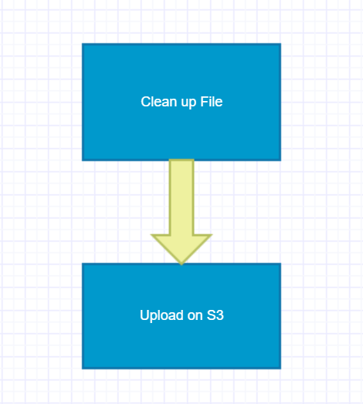

**Luigi Screenshot:**

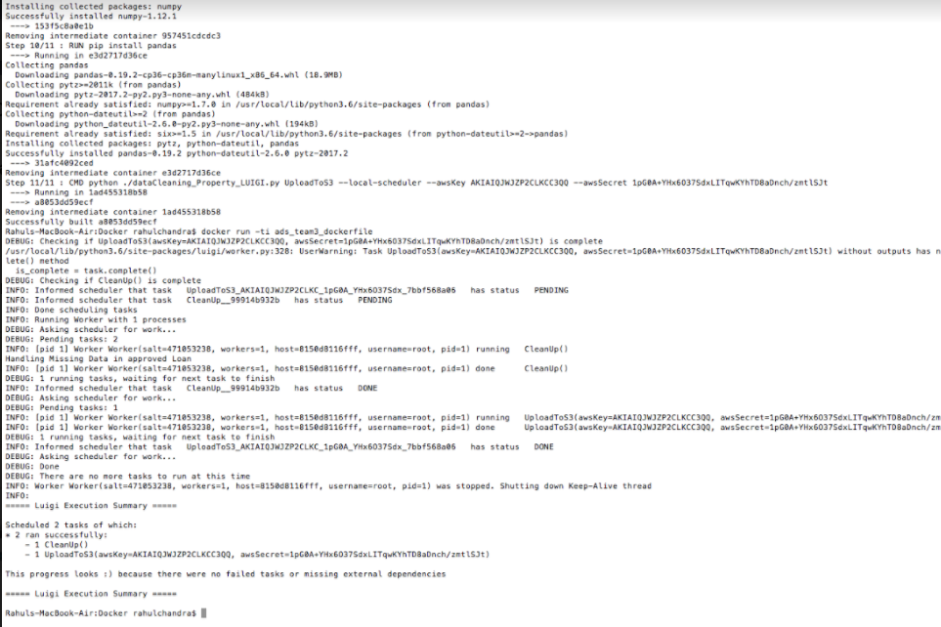

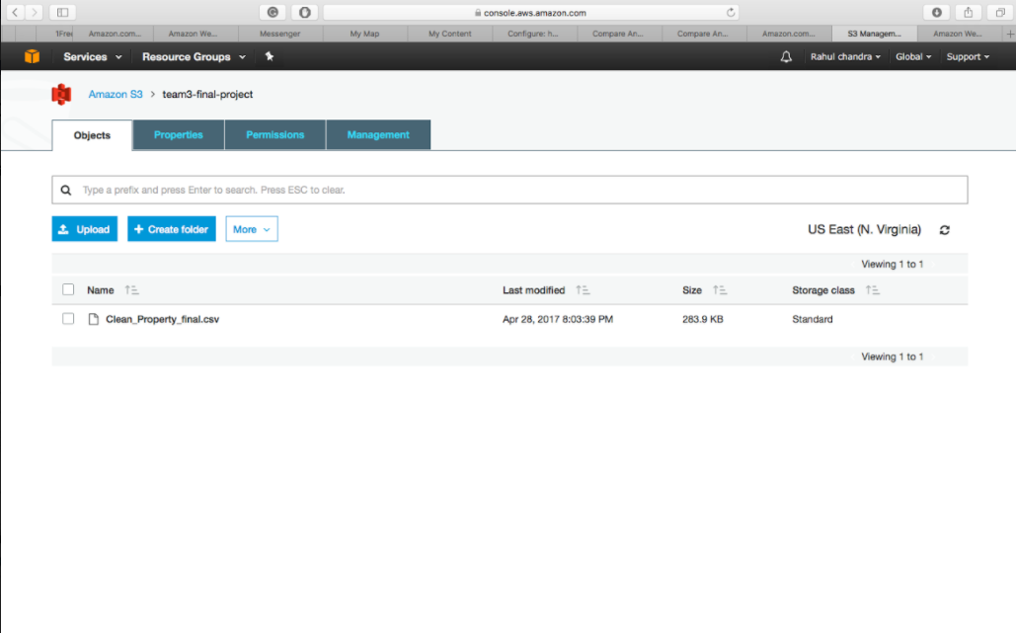

**Docker Implementation:**

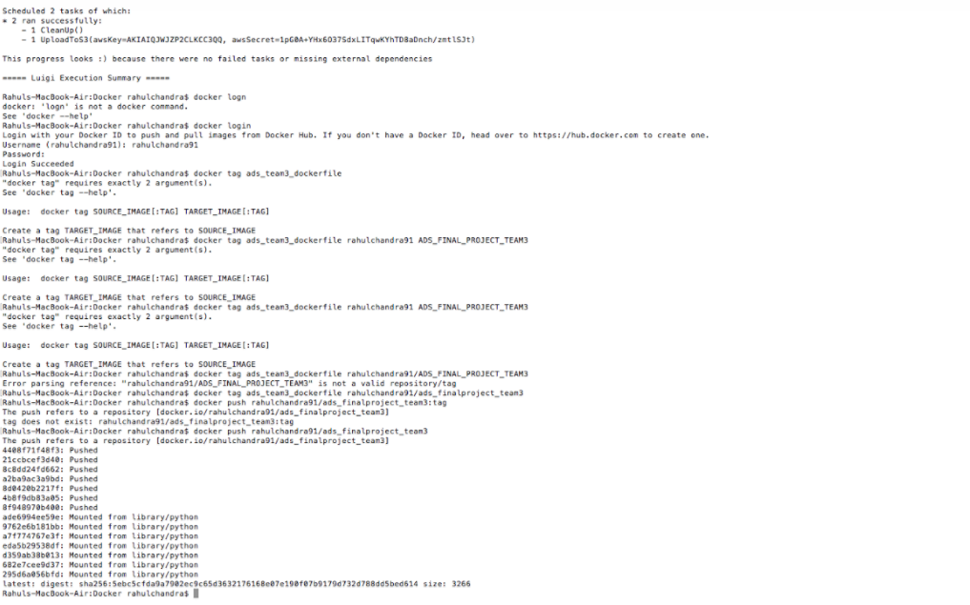

**Flow Diagram:**

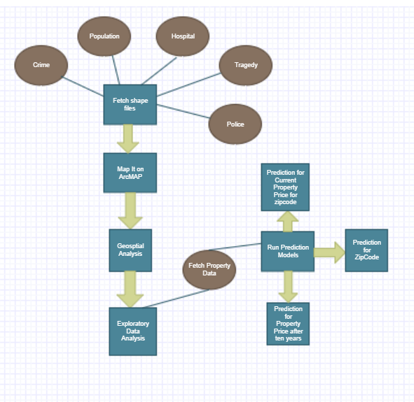

Below are detailed steps of our Geospatial Analysis in ArcMAP.

Step 1: Fetch Data for Crime for entire USA. Fetch Texas bound data to clip crime data from entire USA. We shall make use of clip functionality from ArcMAP.

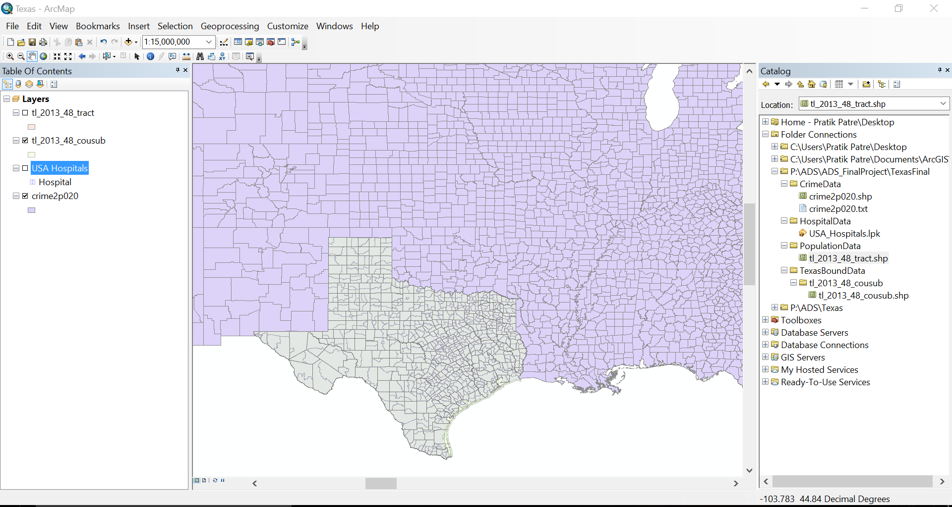

Step 2: We use the Clip Functionality to cut the Texas Crime data from USA Crime data. The input Feature will have the entire USA Crime Data. Clip Feature will be Texas State Data. Output Feature Class will be Texas Crime Data.

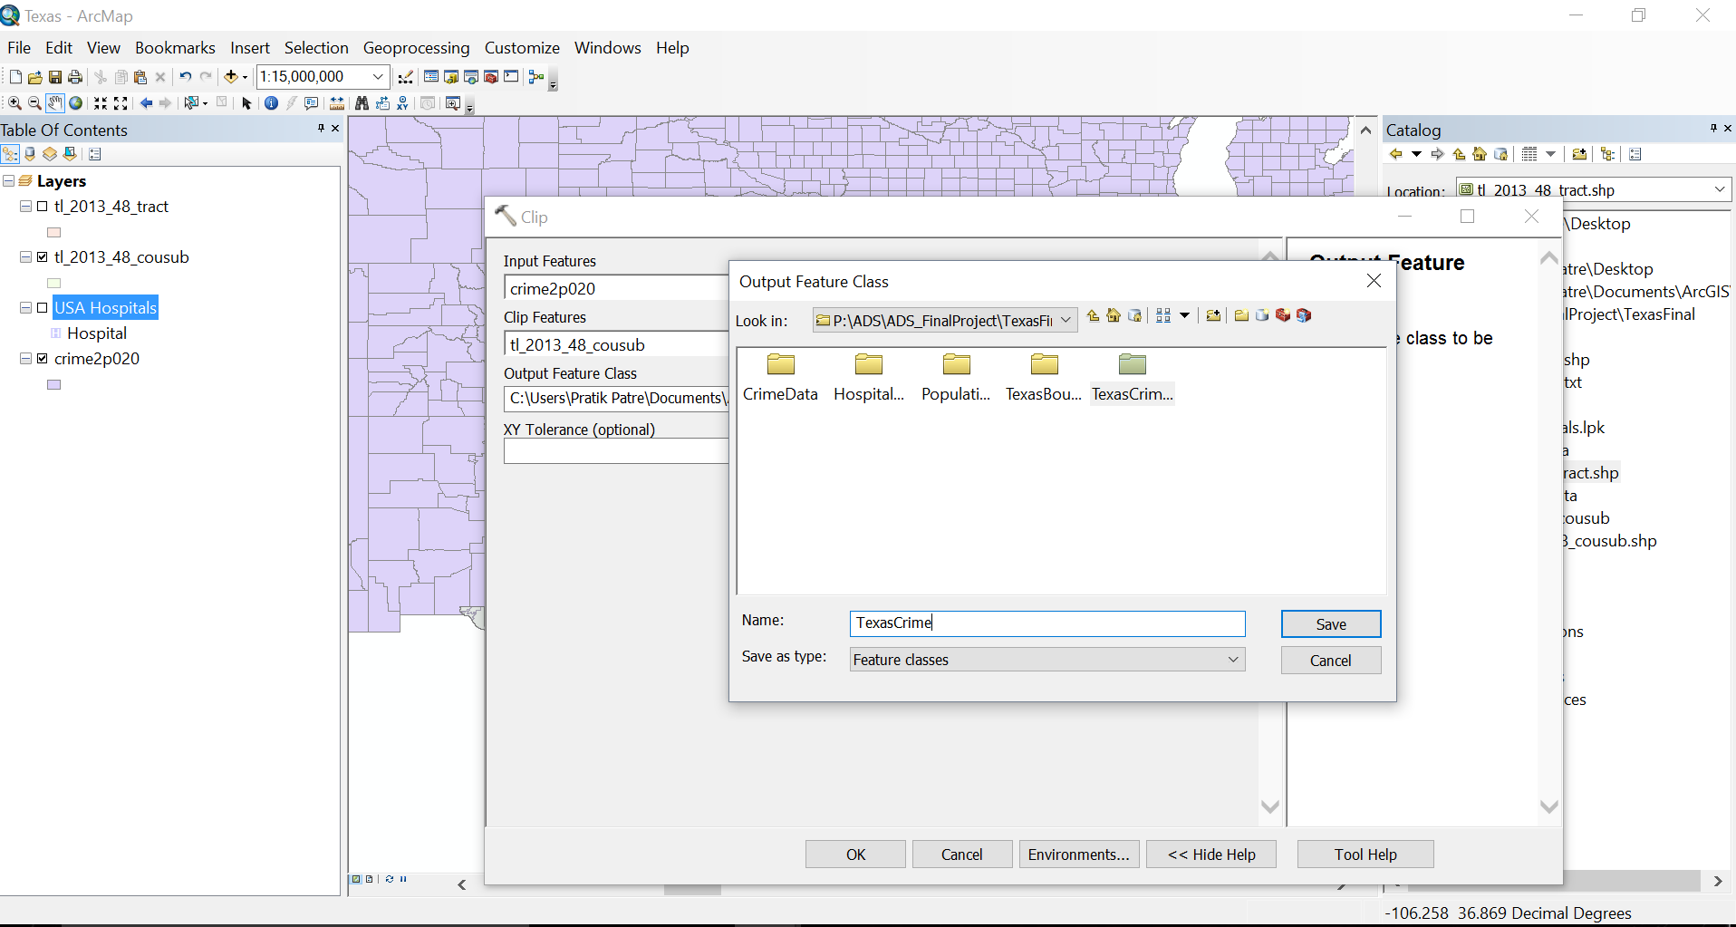

The output will be a clipped Texas Crime Data as below.

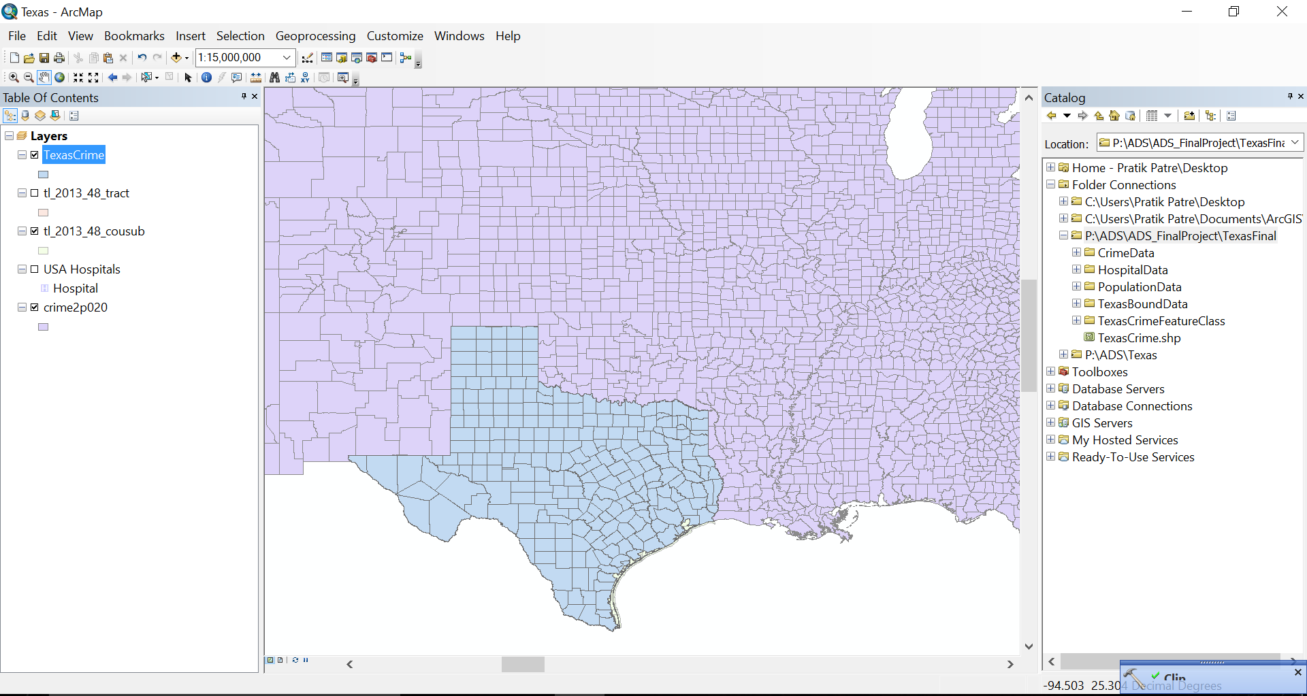

Step 3: We repeat the above steps for Clipping Hospital Data for Texas.

Before Clipping:

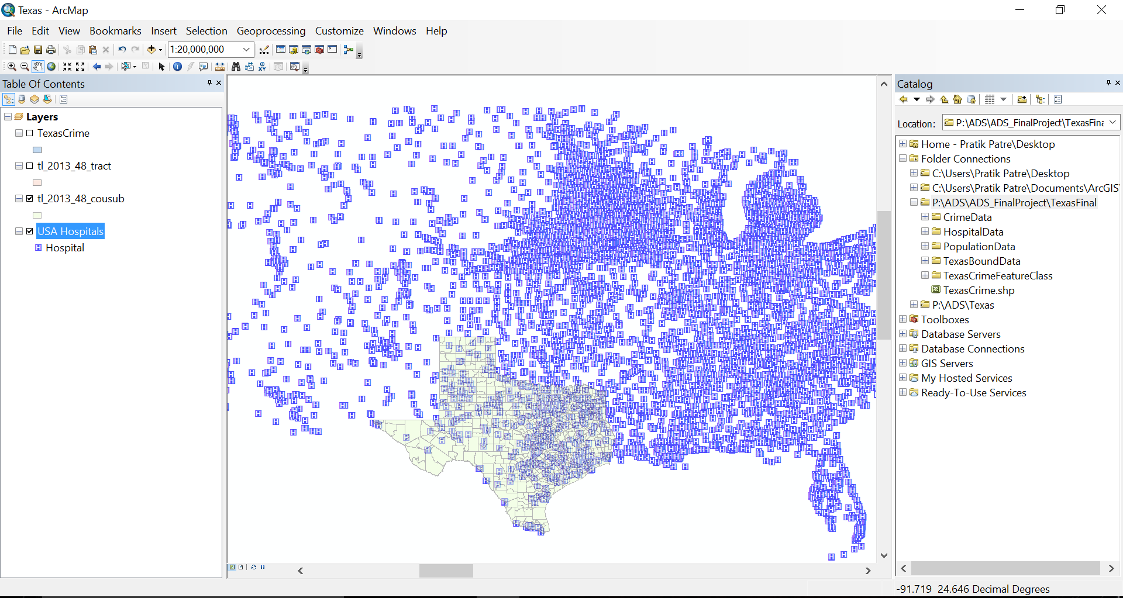

After Clipping:

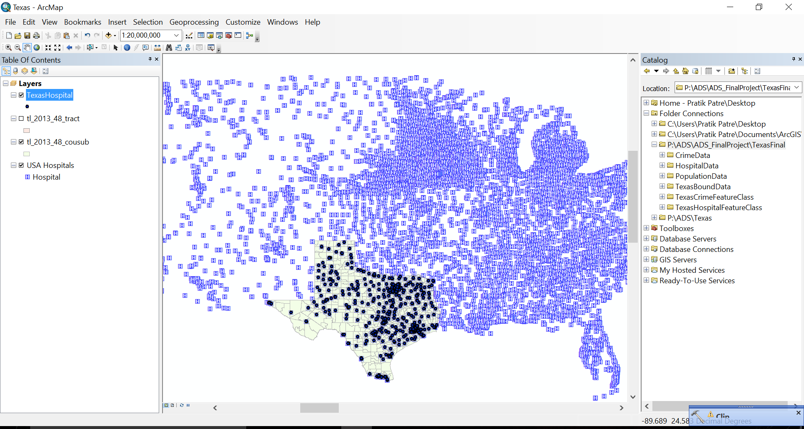

After Turning off the Hospital Data for entire US.

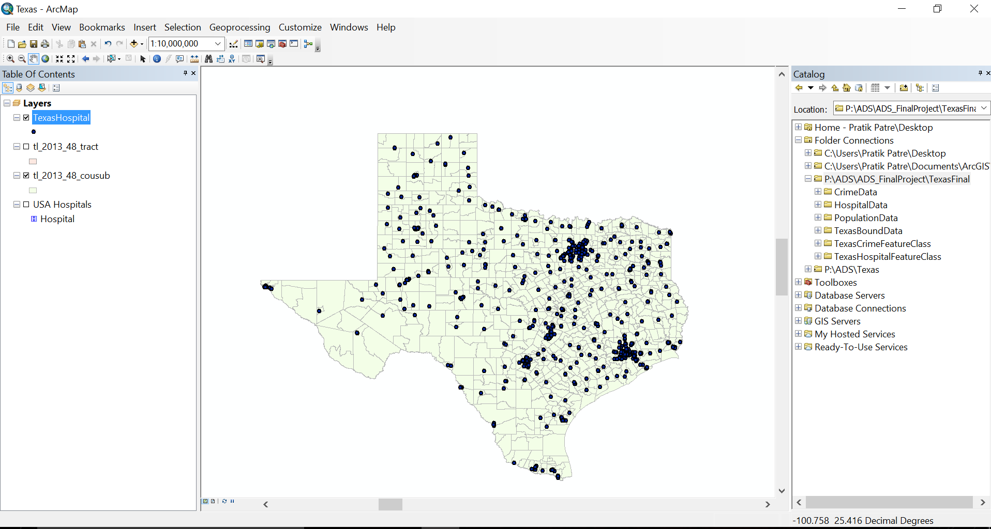

Step 4: We will repeat the above steps for finding the ZIPCODES for Texas now.

Before Clipping:

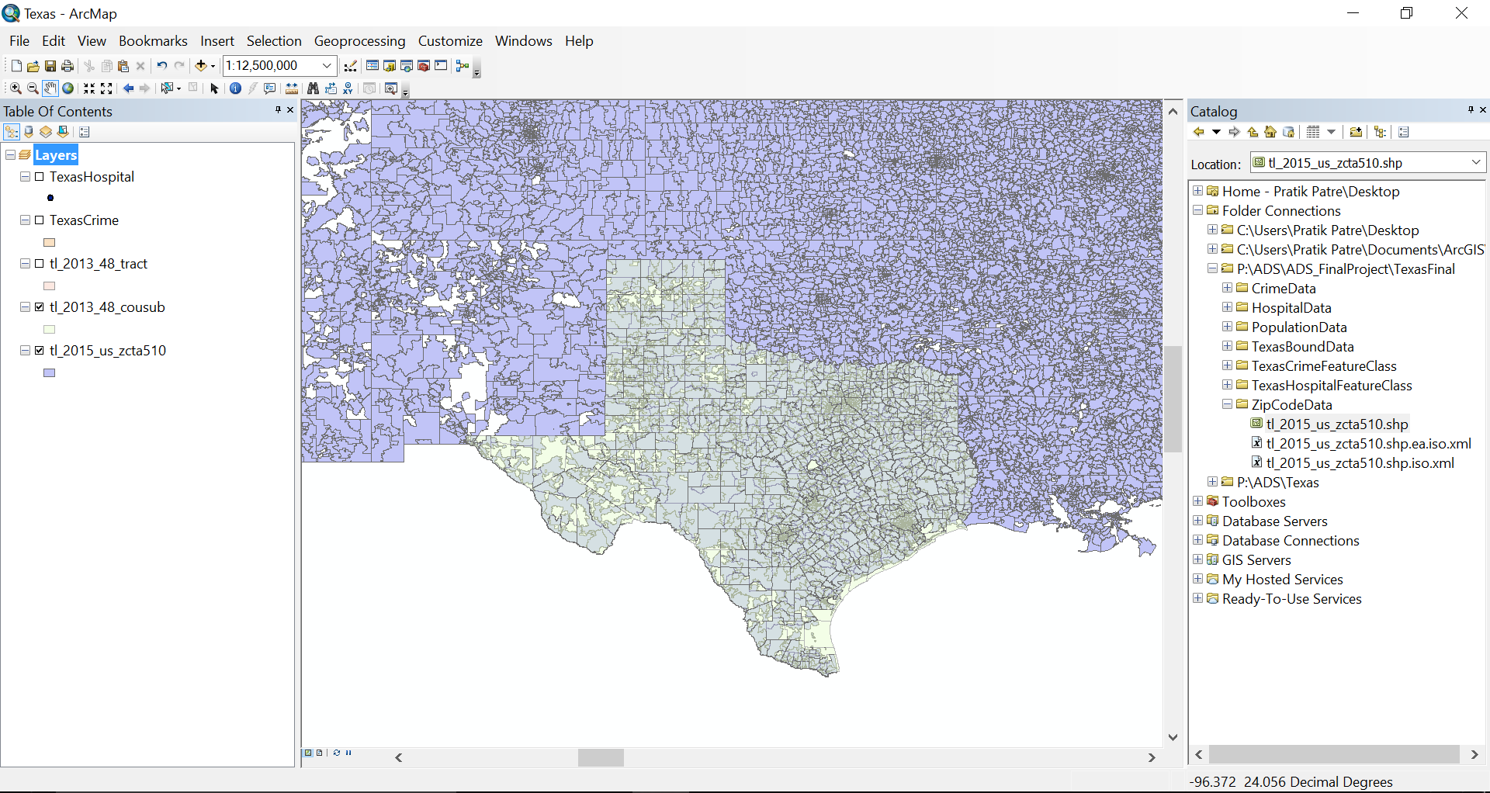

After Clipping:

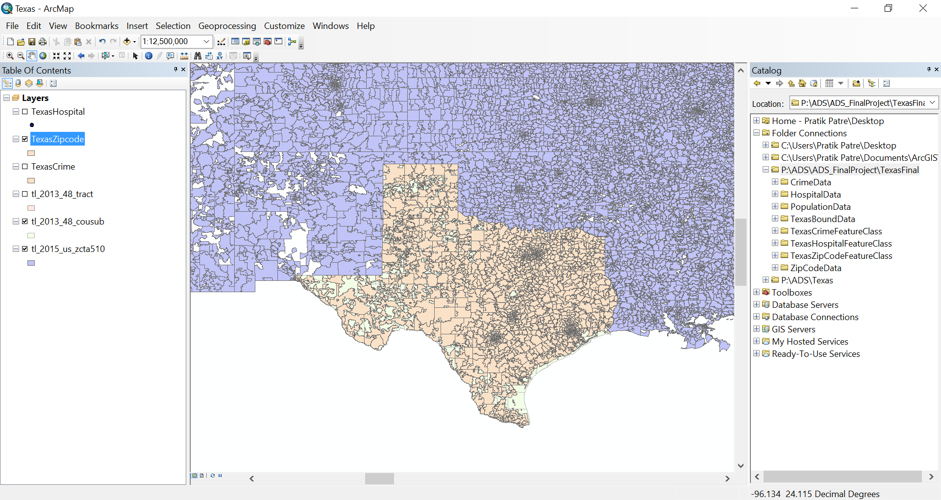

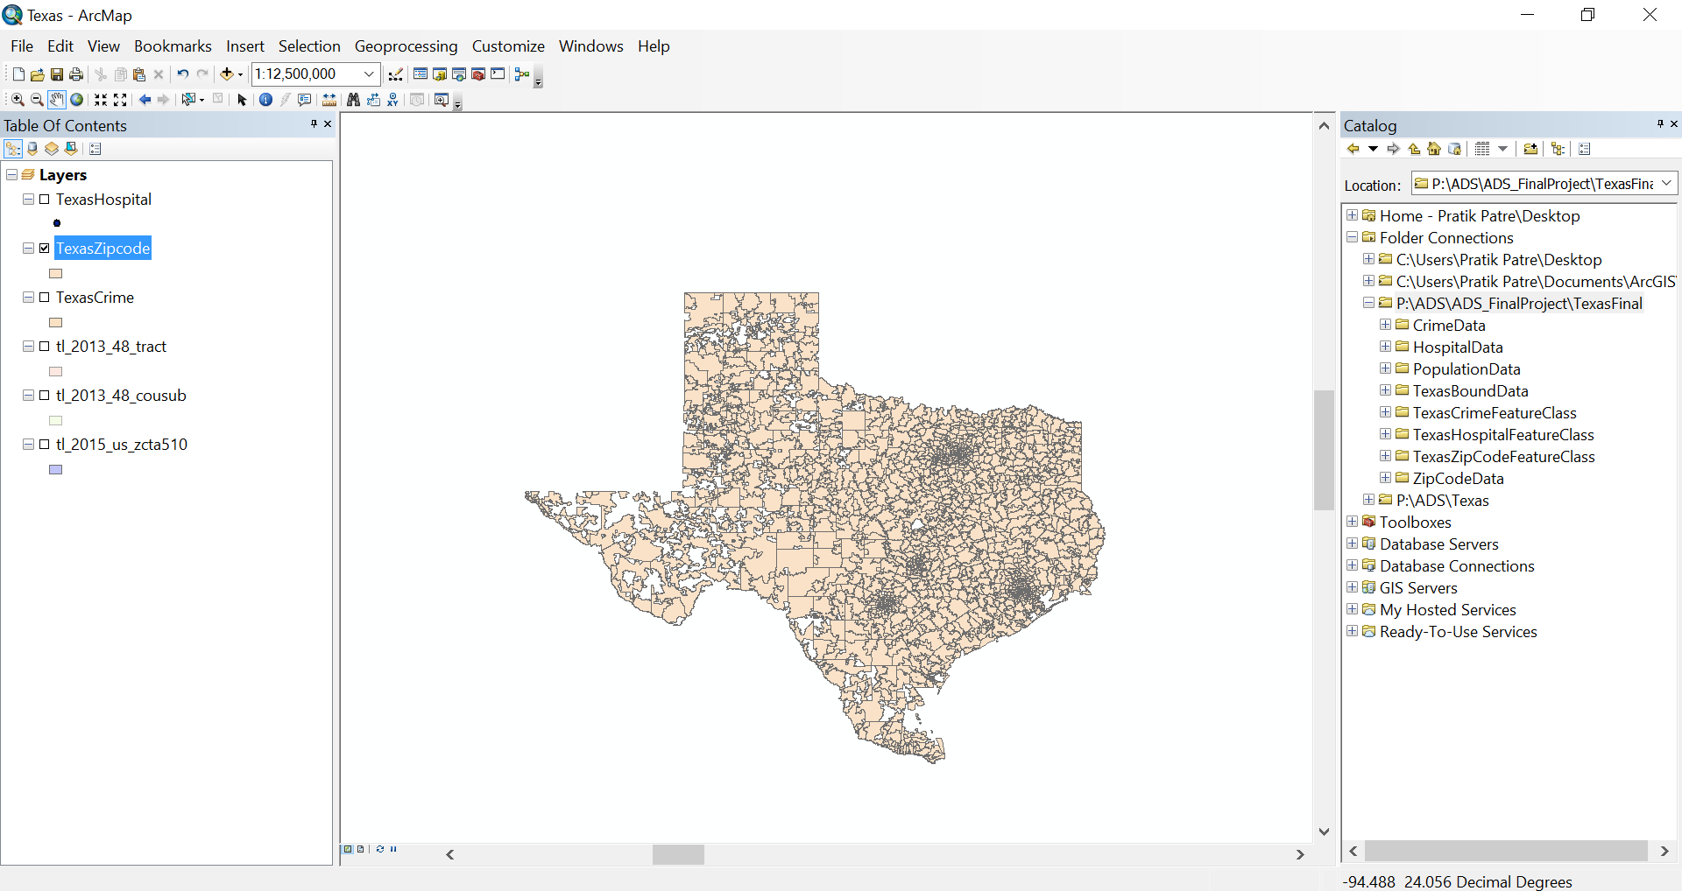

Step 5: Merge Zipcode and County Feature Class together to get a dataset Feature class which consists of both the attributes. We use the Intersect Functionality to proceed with this step. As below, we merge dataset TexasZipCode with County to get ZipCountyMerge.

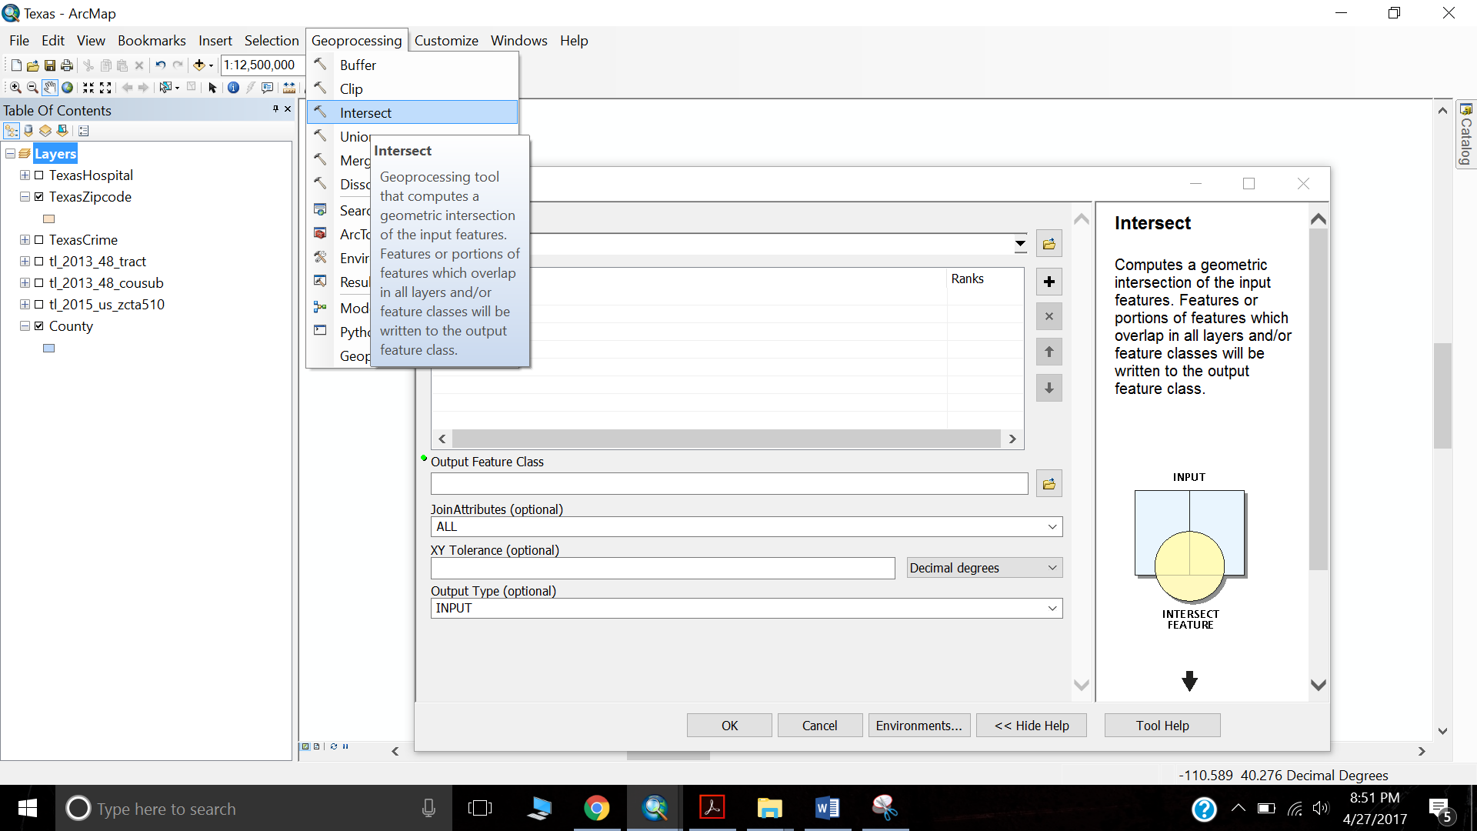

Output File:

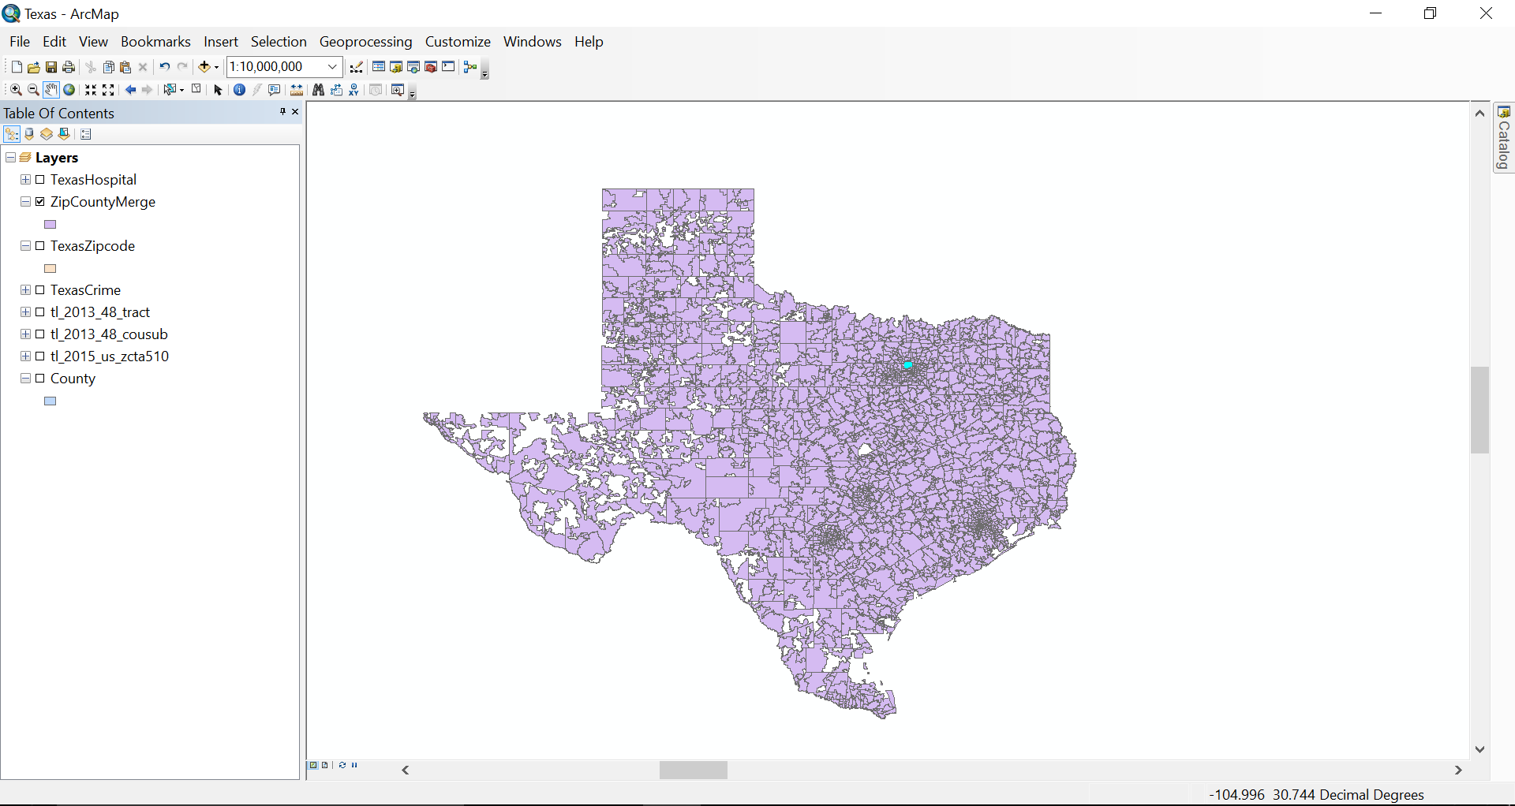

Step 6: Now that we have Zip code and County Data in one, we further now count the number of hospitals in every zip code of each of the Counties. We shall get a Feature Class which will consist of dataset containing number of Hospitals. We make use of Spatial Join in ArcToolBox to do this.

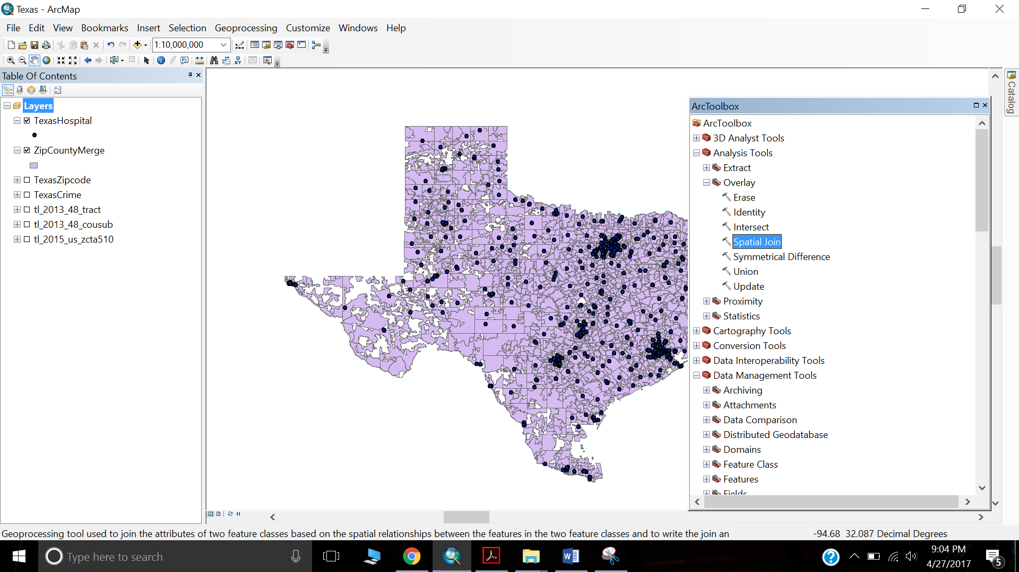

The number of Hospitals can be counted by giving the Hospital Feature class in Join Features.

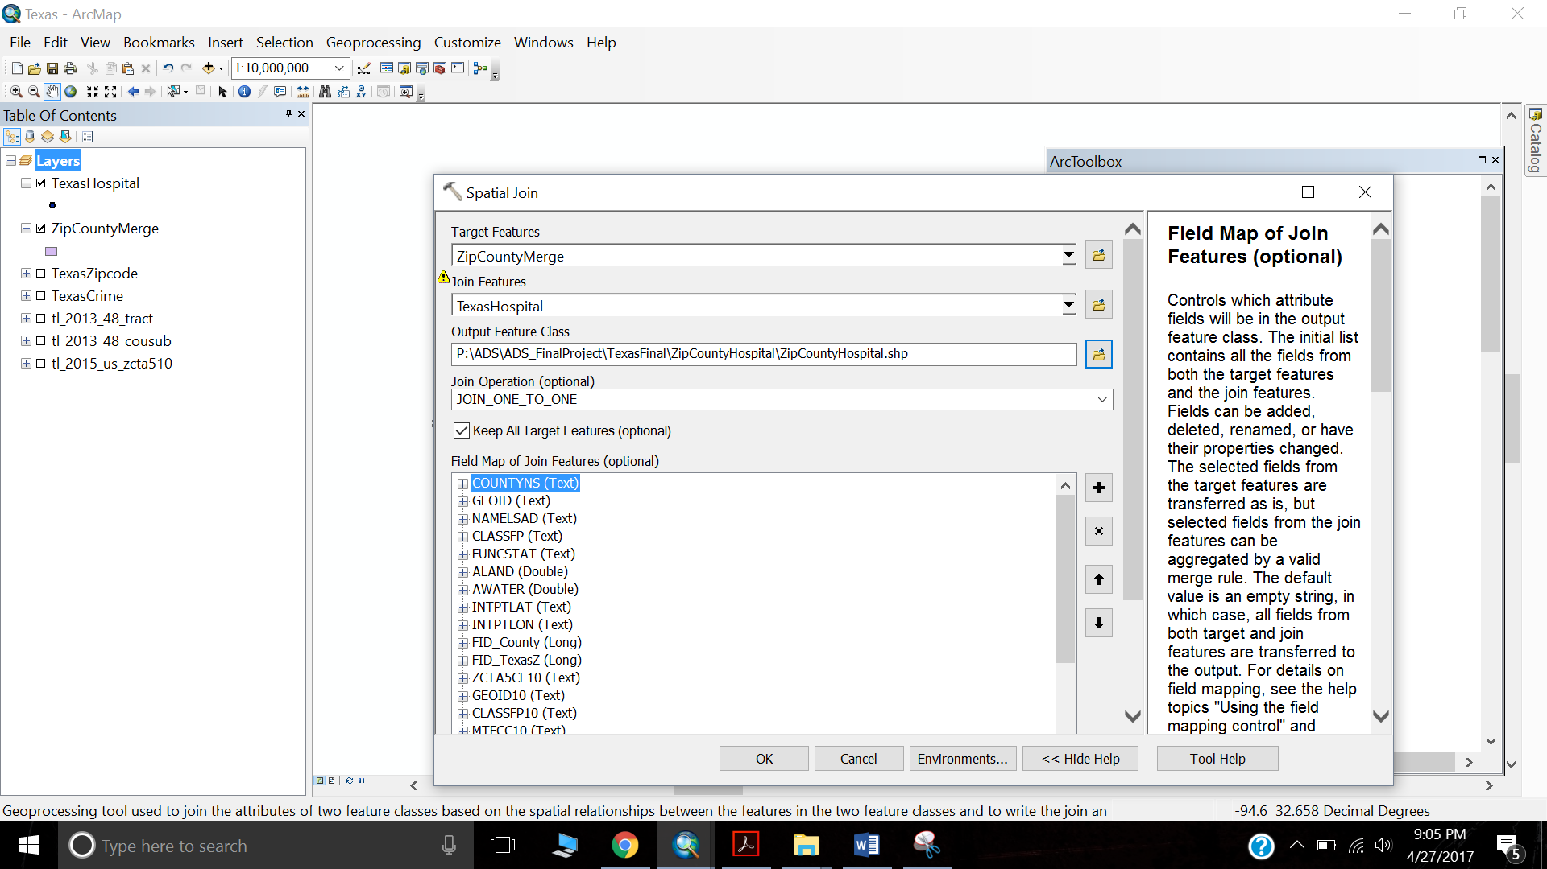

The new Feature class named ZipCountyHospital will consist of total number of hospitals in each of the zipcodes. The Join_Count column will contain the number of Hospitals. To check whether the number is correct we can verify it by using TexasHospital data over TexasCountyHospital and then visually cross checking for one or two Field. Please refer the below image.

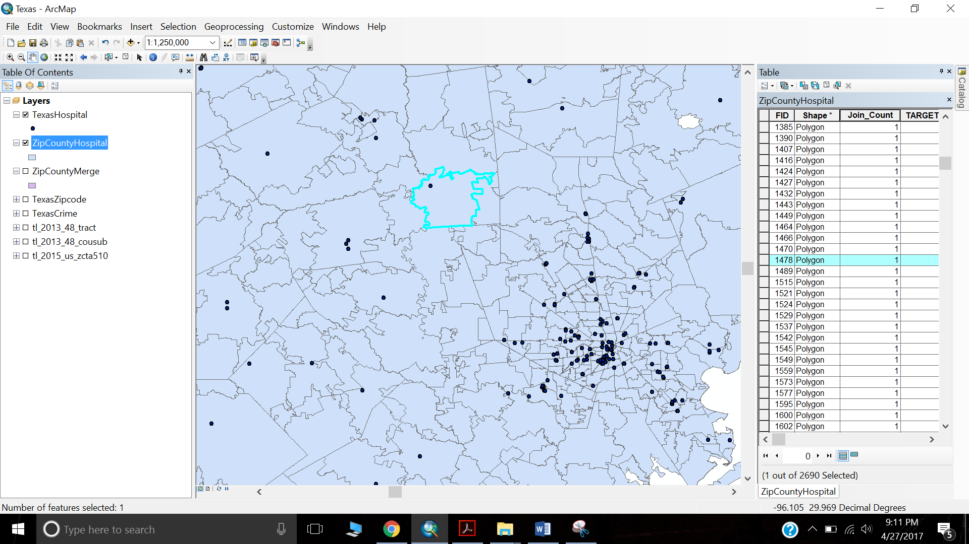

**We are done with analyzing and getting Hospital data in proper form.**

Step 7: We further will now calculate the density of crime for each of the zipcode. We calculate the density by using the formula INDEX/AREA. We have Index for this data. Now We must calculate the area for each of the zipcodes. We add a new field by Selecting Add field in Table Attribute. We further Select the Area column and go to calculate geometry. Calculate geometry can be used for calculating X and Y coordinates or Area or Perimeter of a polygon. The below images will give a brief description of how to achieve this.

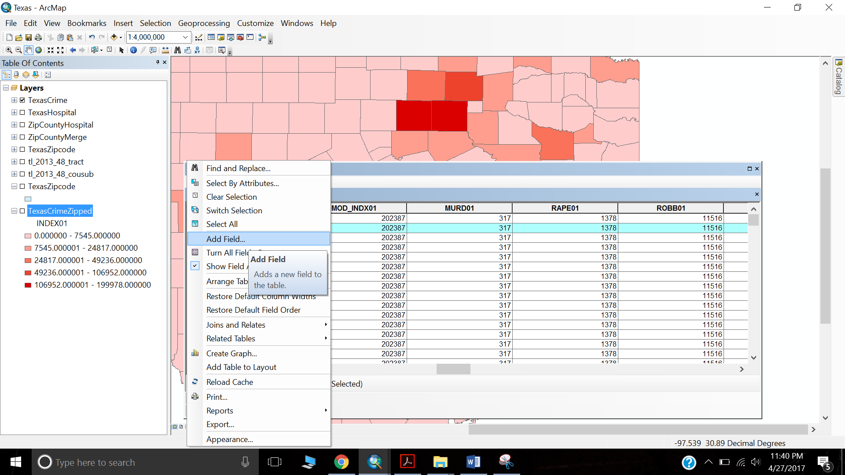

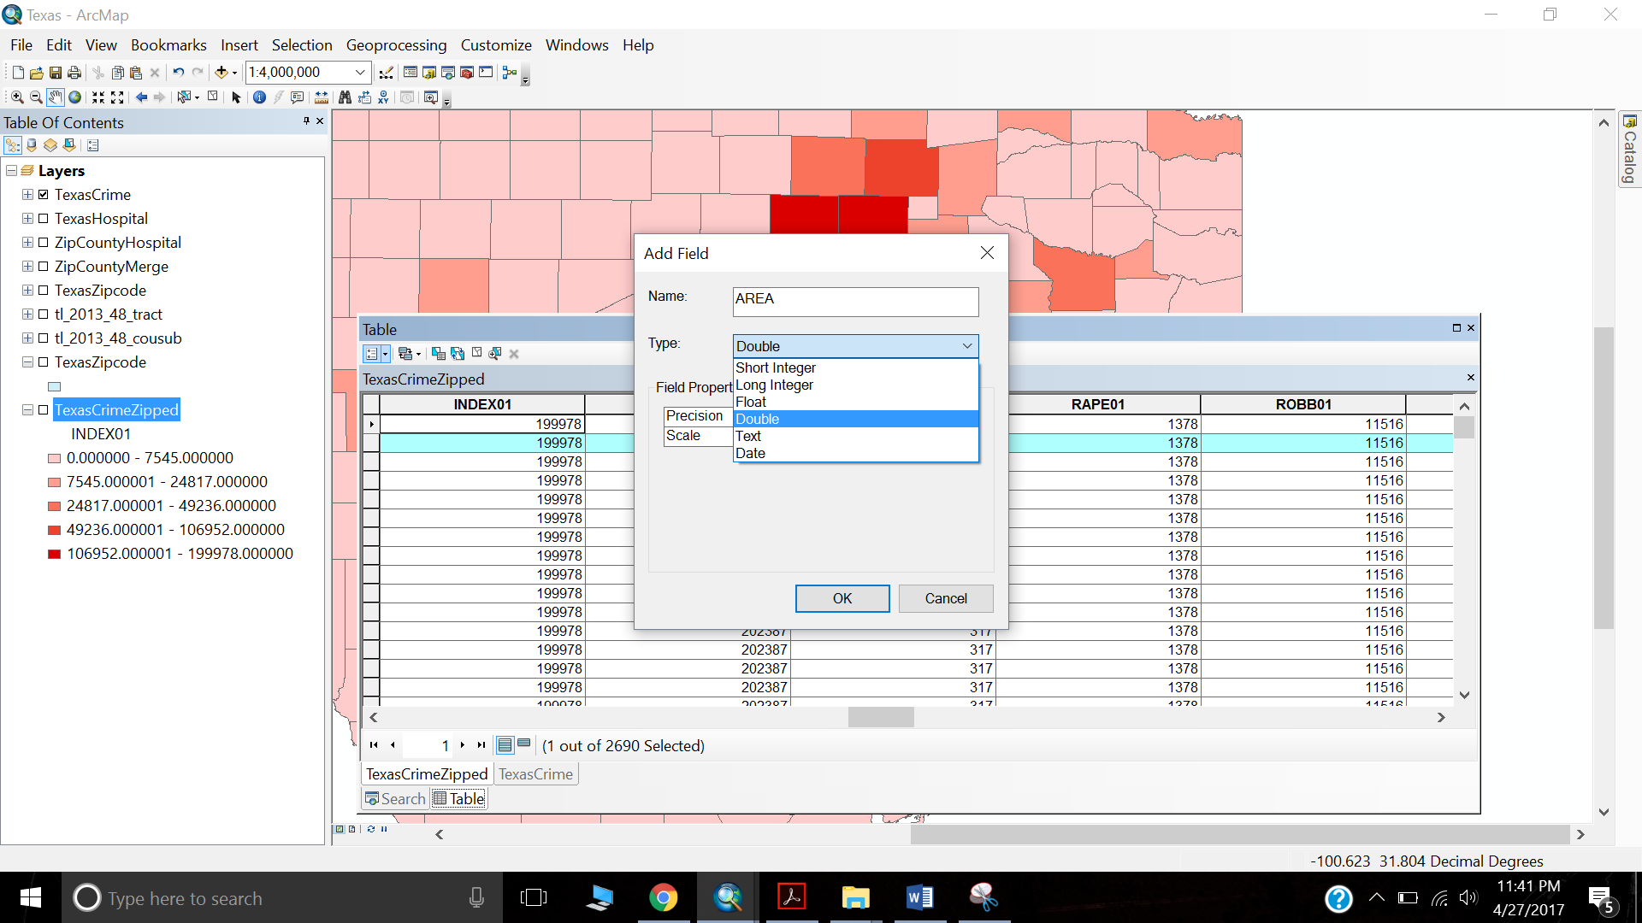

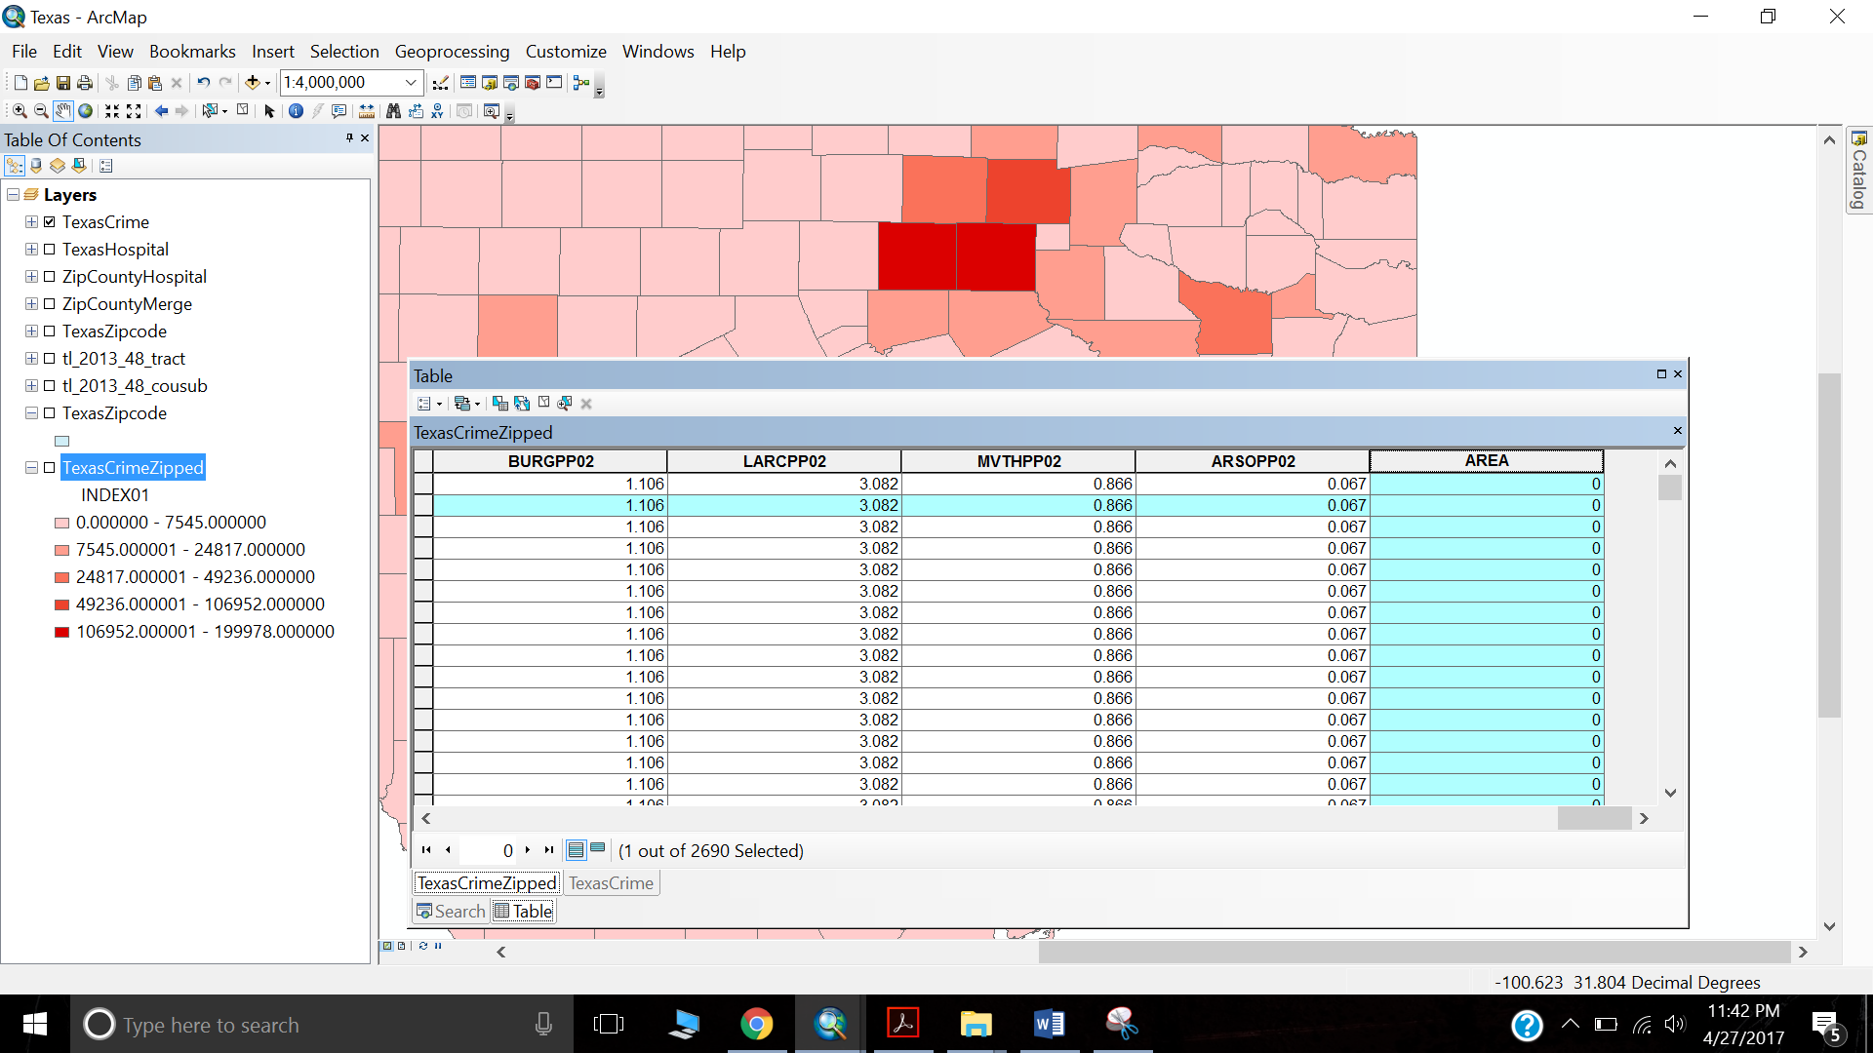

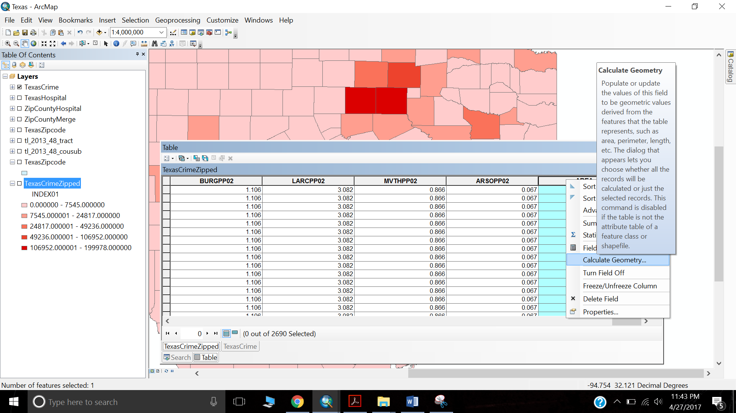

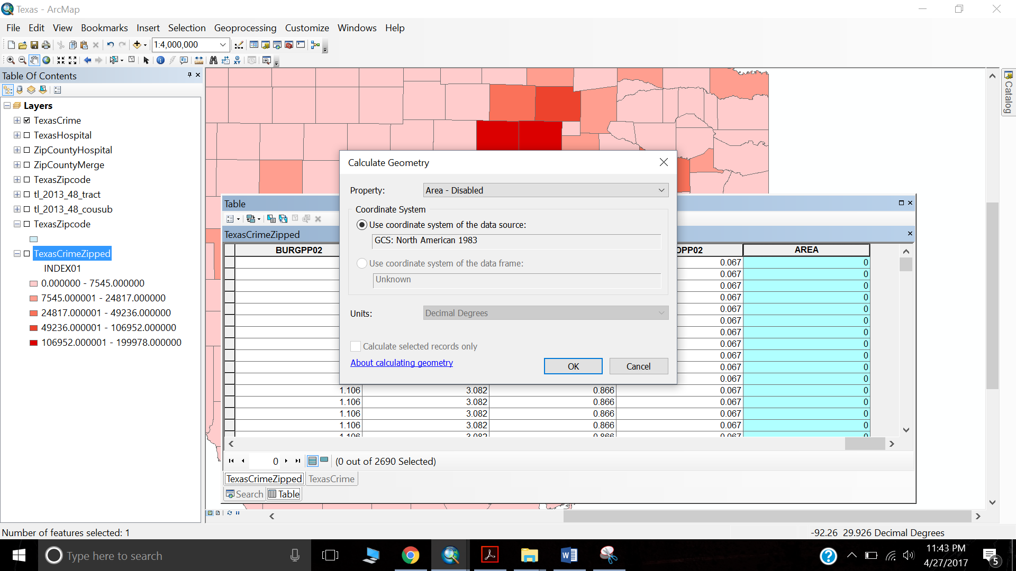

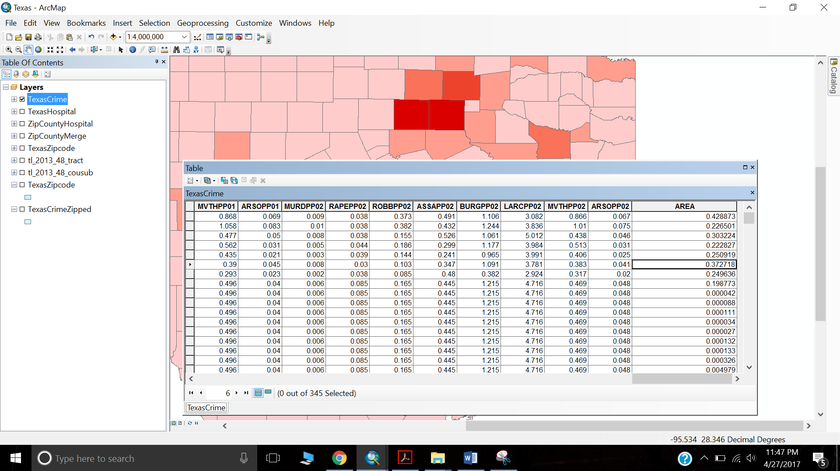

Step 8: Crime Data of Texas has INDEX which gives us CRIME RATE. Now it is important to map this index with each of the zipcodes of a county. So, we join the TexasCrime Data with TexasCrimeZipped (ZIP+COUNTY) mapped dataset. We make use of Join to join data from both dataset.

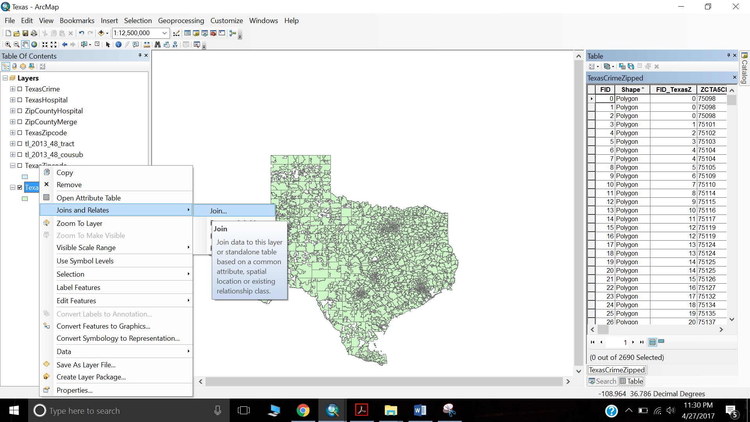

Before We map the zipcodes with TexasCounty dataset:

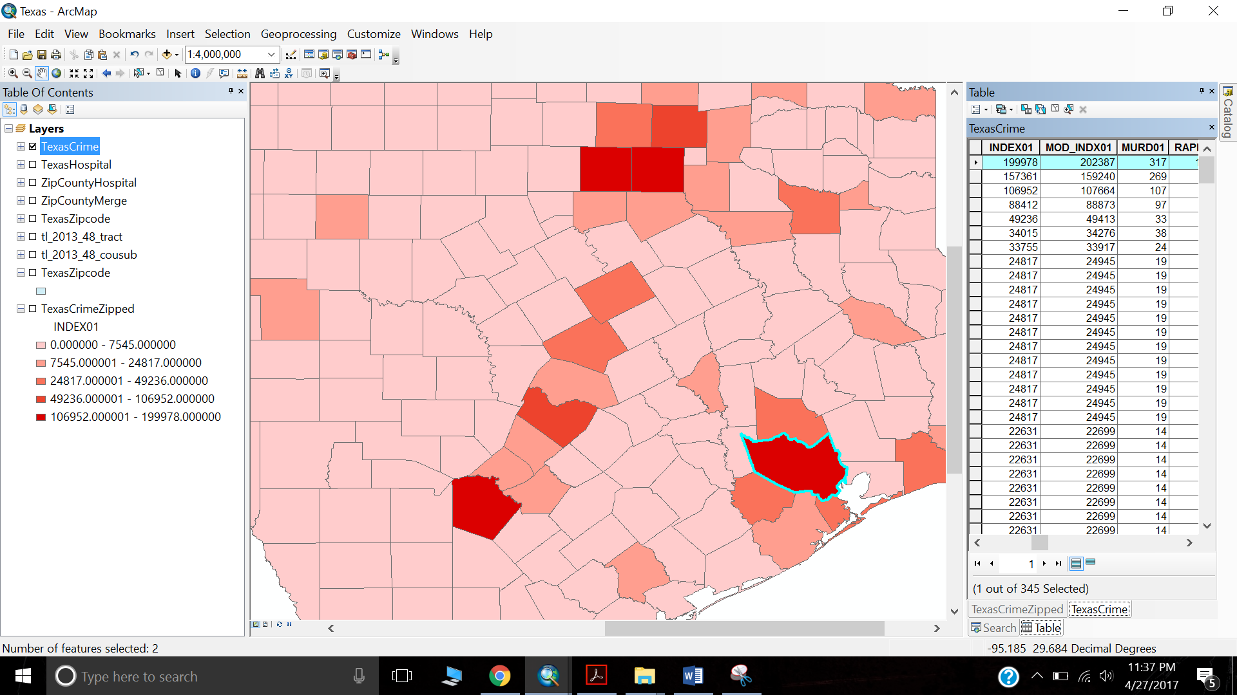

After we map the zipcodes with TexasCrime dataset:

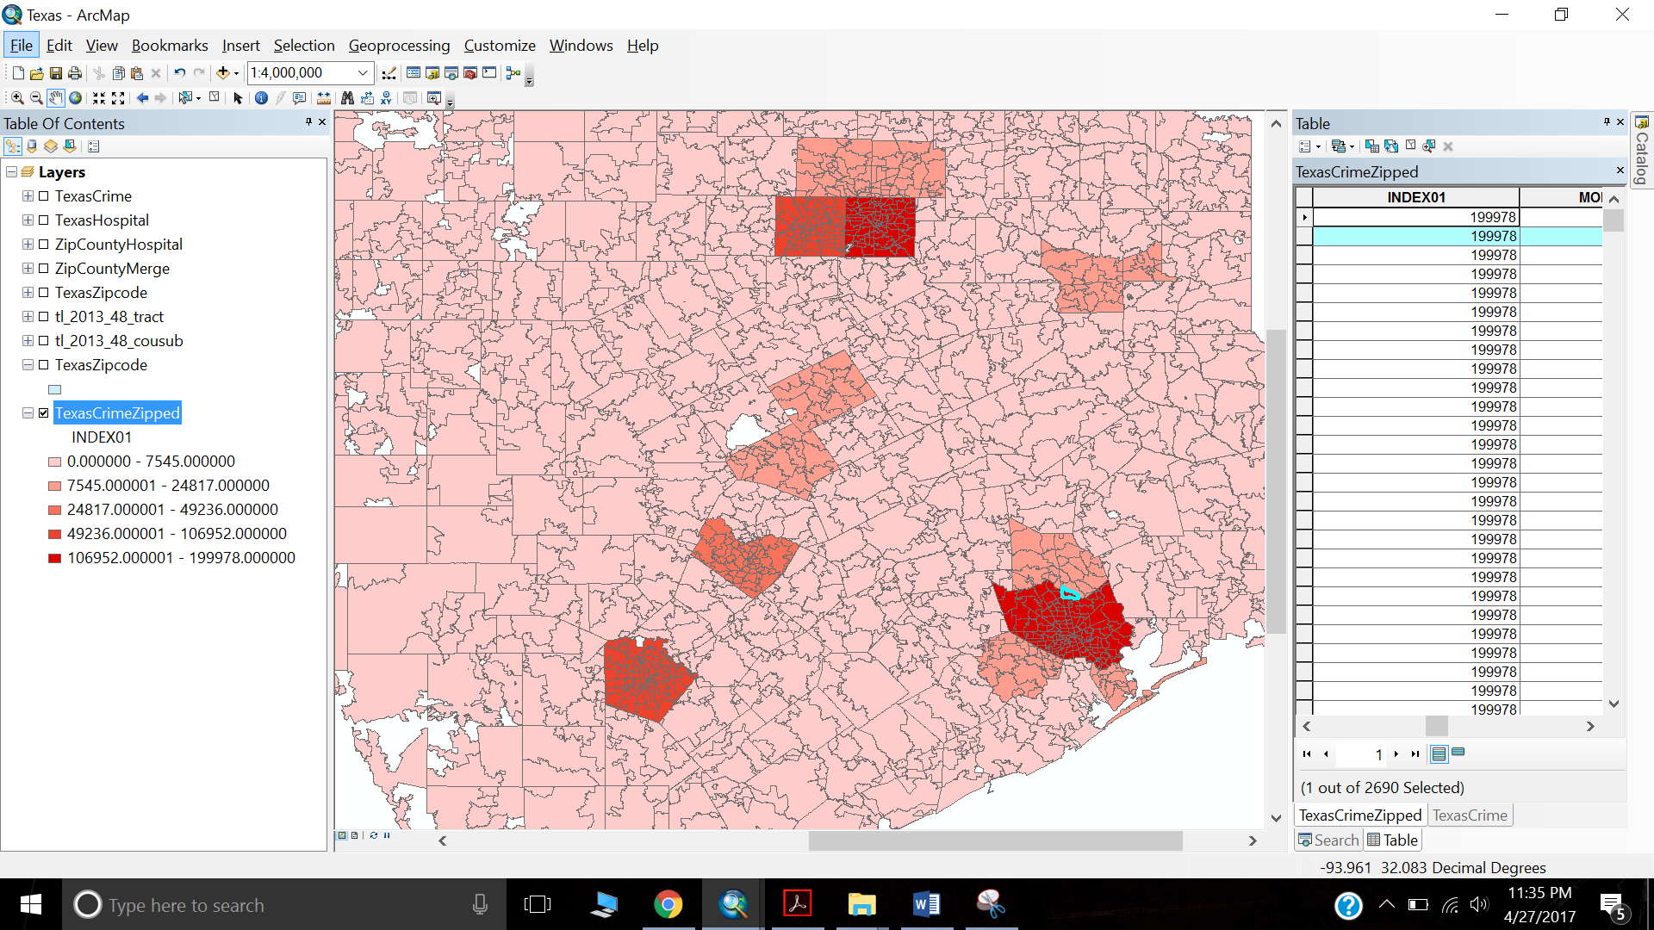

Step 9: Now we are ready to calculate the Density by the formula INDEX/AREA.

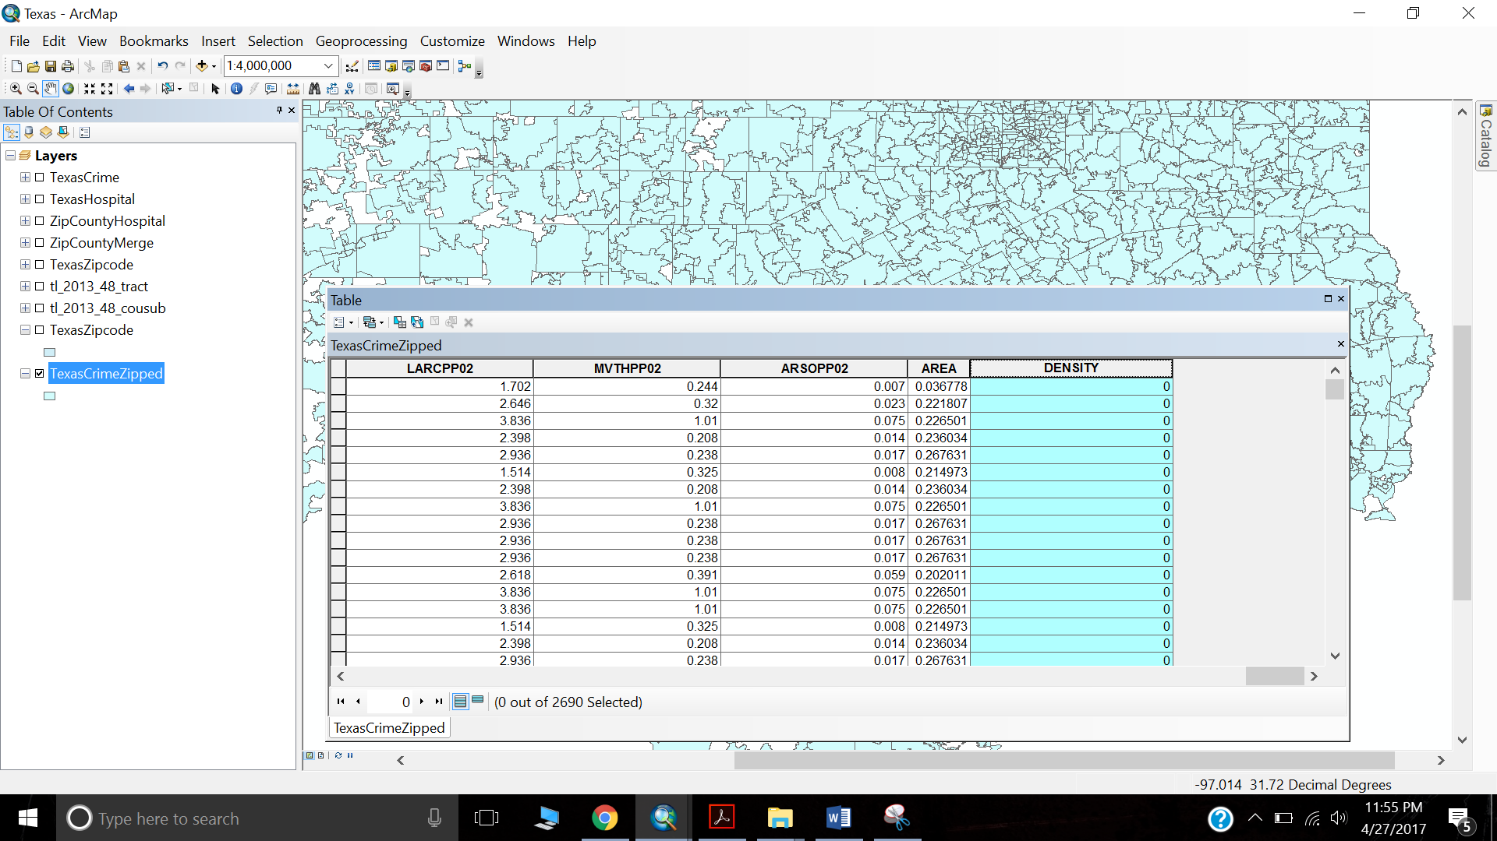

We make use of Field Calculator to calculate the density.

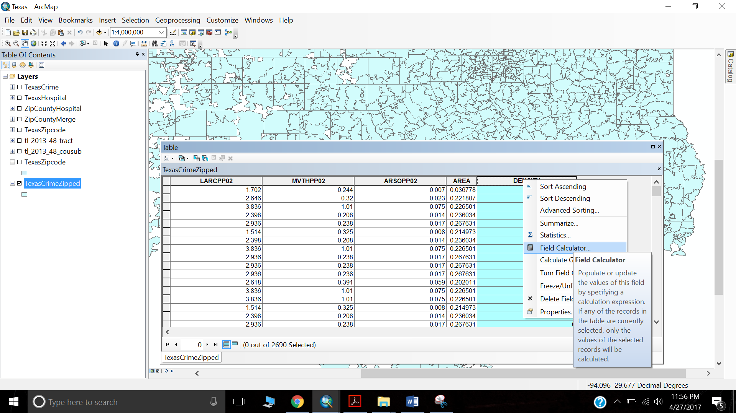

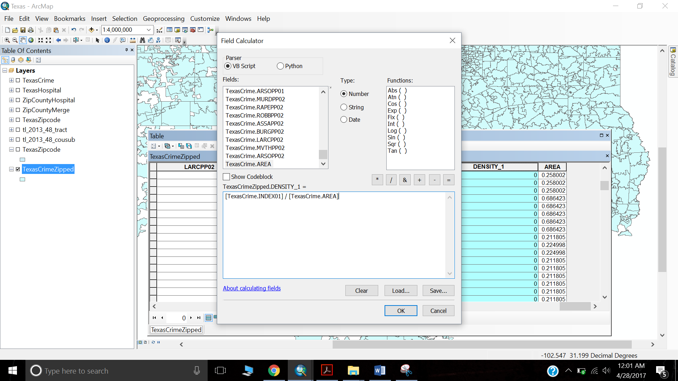

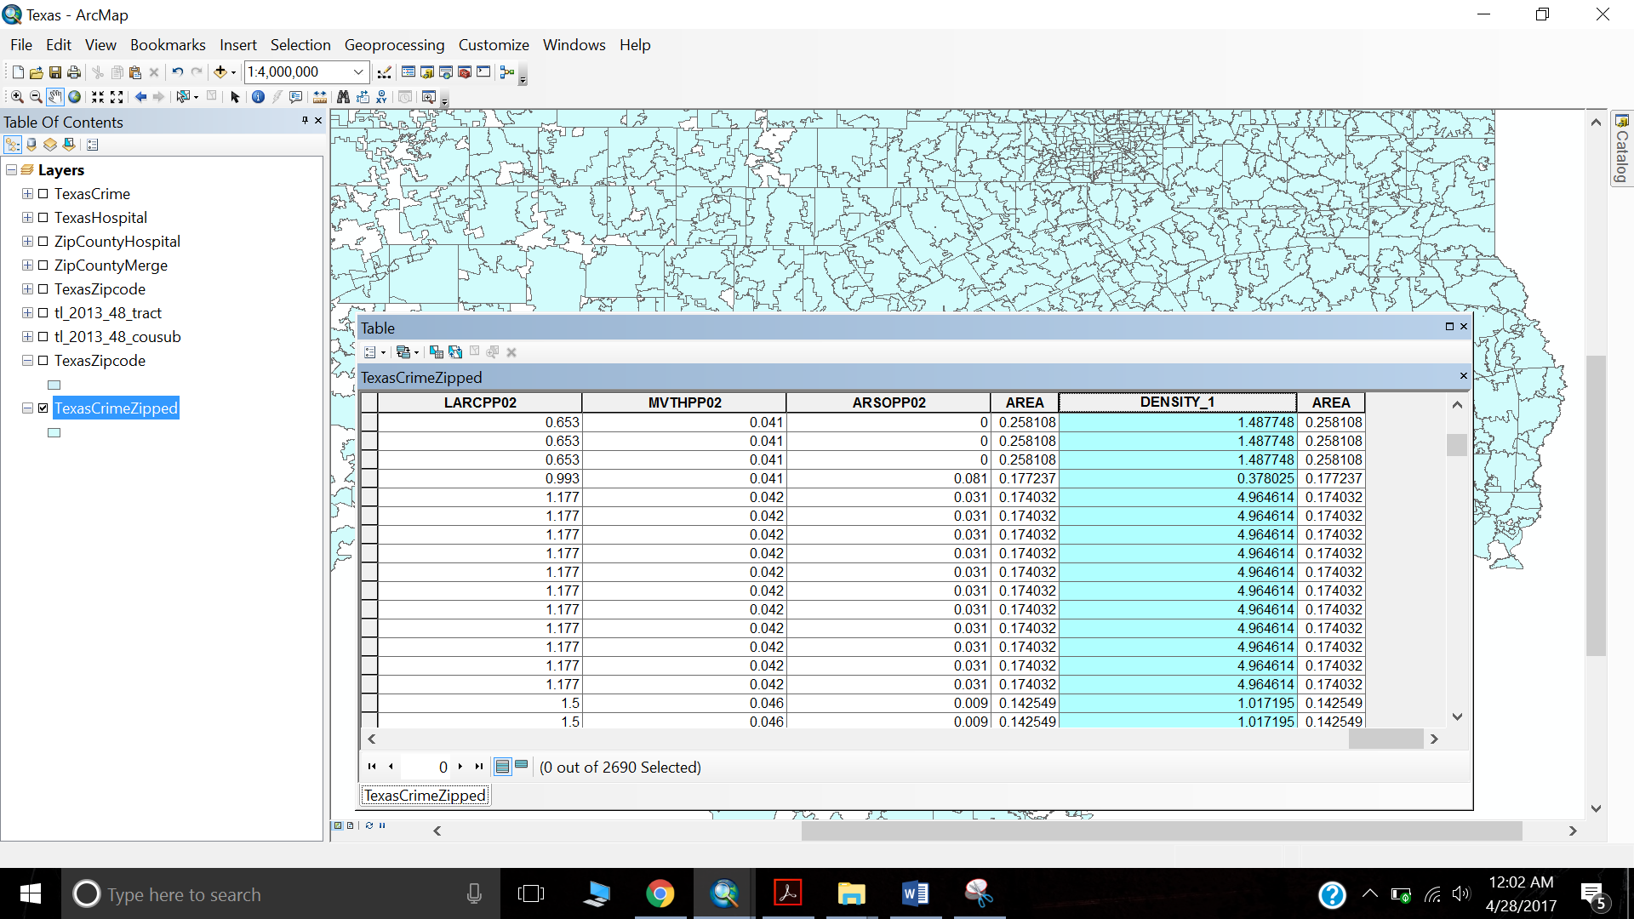

**We are done with Analysing Crime Data and getting it in proper form.**

Step 10: Now we do not have Police data of Texas as a shape file. So, it would not be possible to map this data on ArcMap. We need to import csv to ArcMAP first. We Add Data

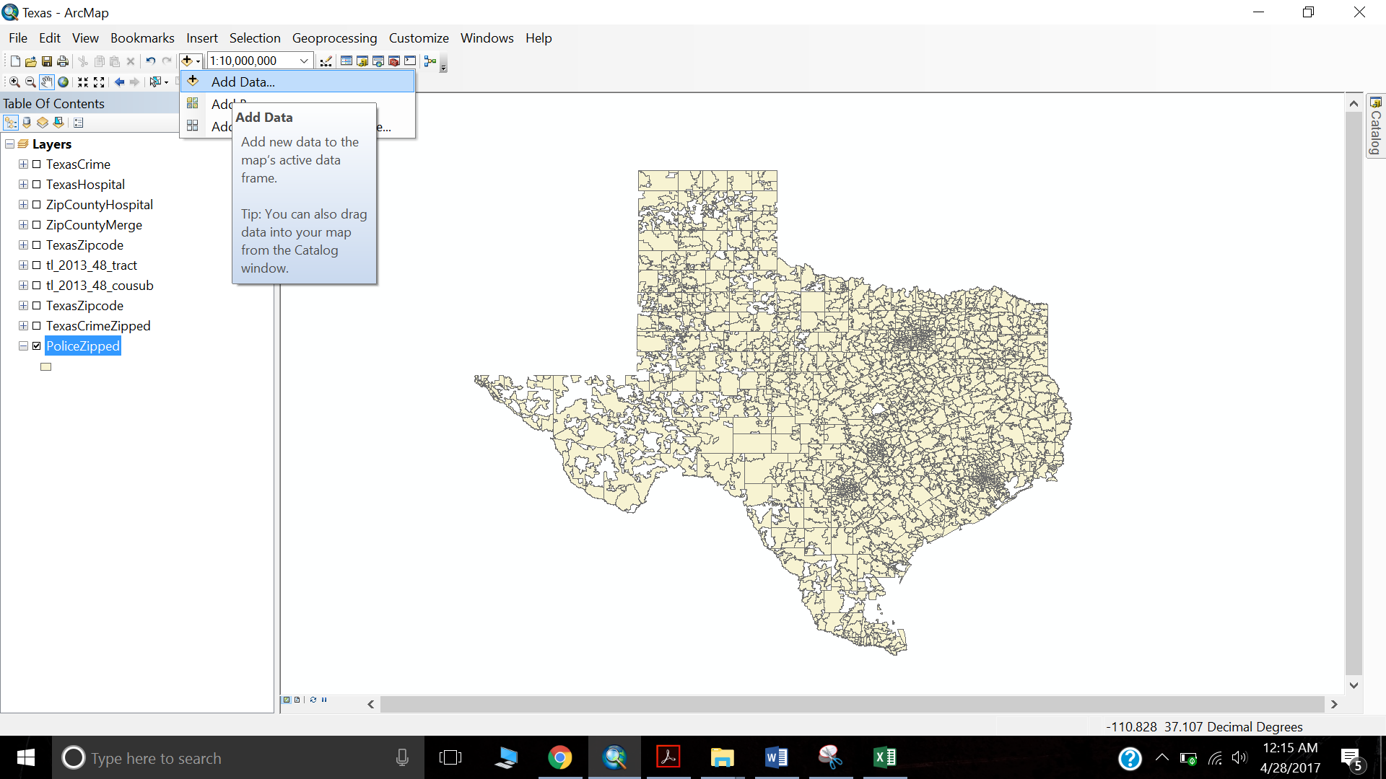

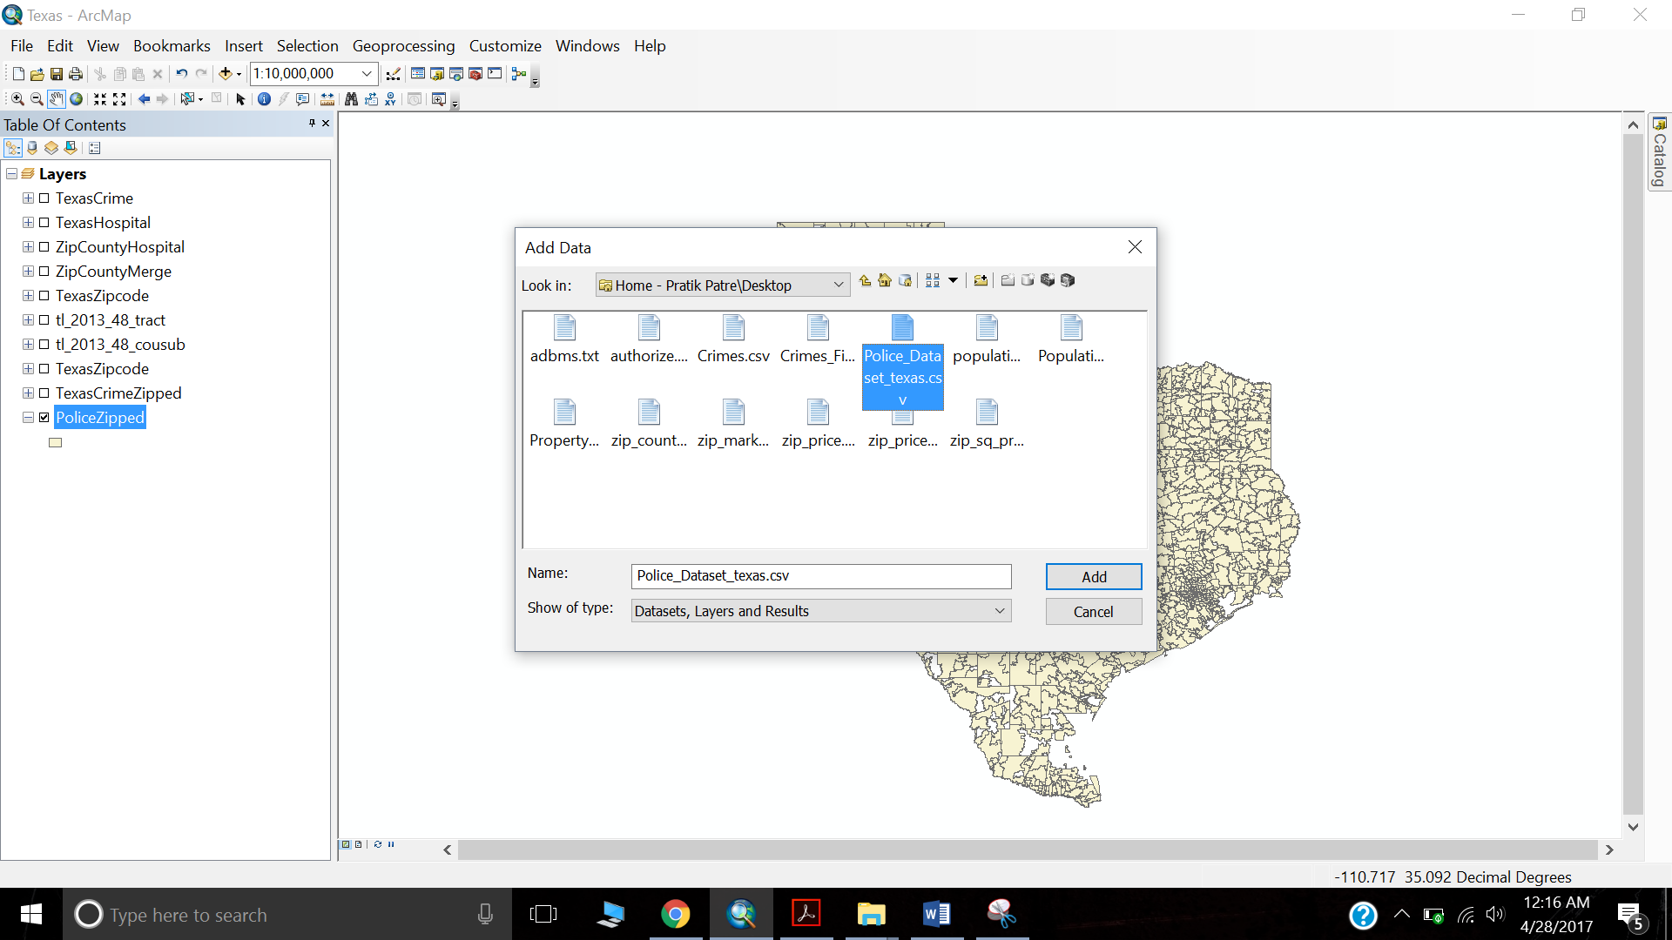

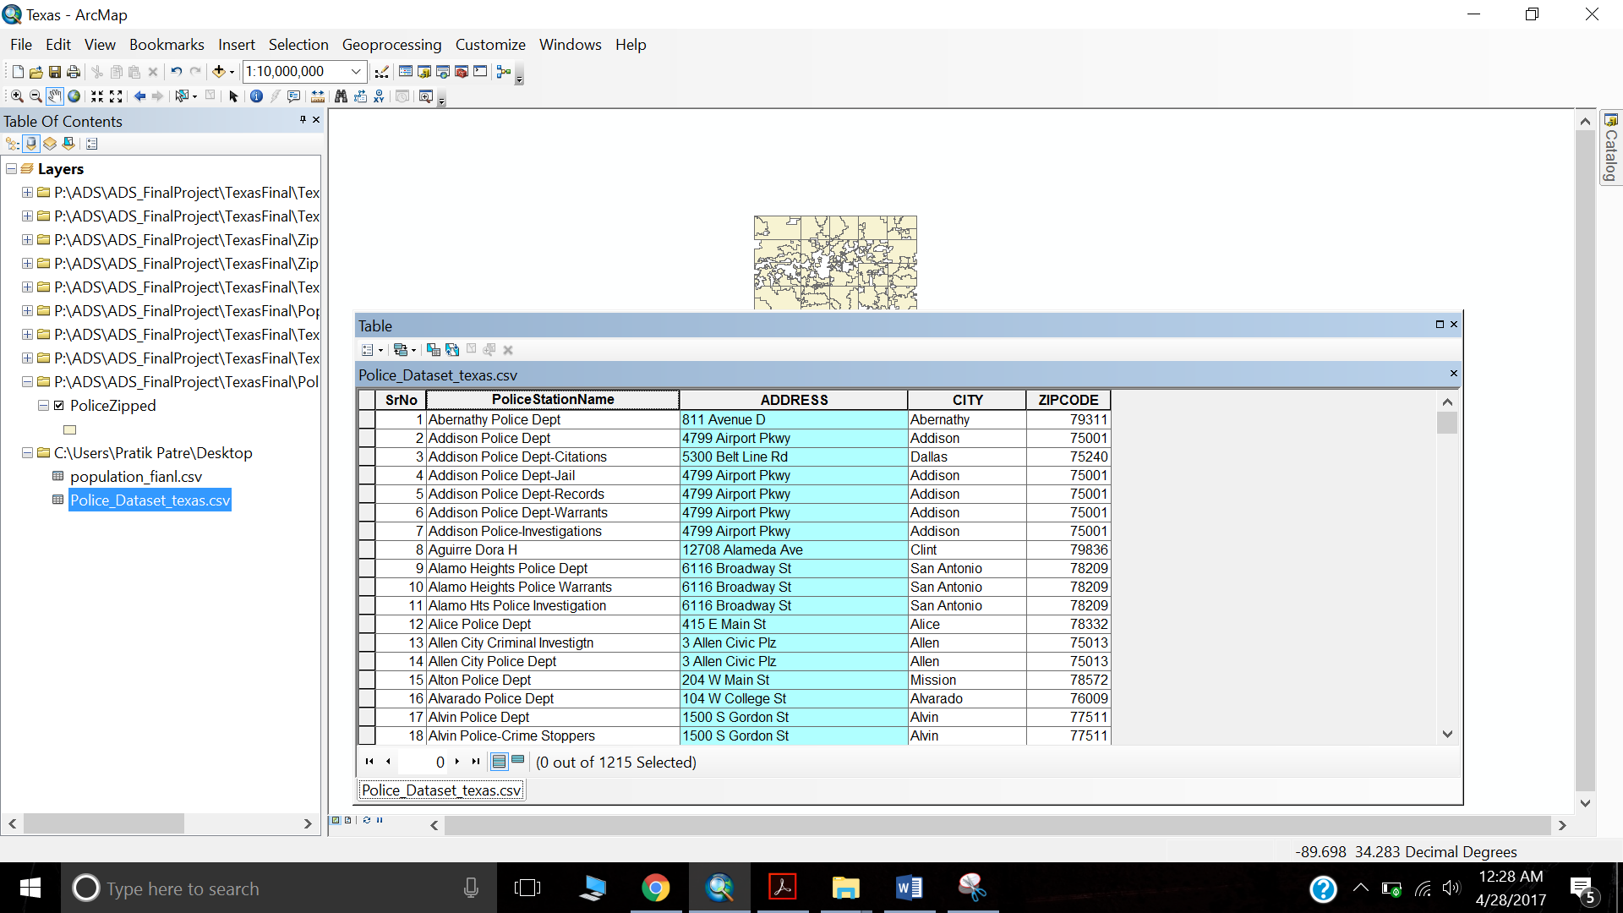

Step 11: Now that we have imported csv data, to map it, we can join this data to ZipCounty data since we have zip code attribute in our Police Data.

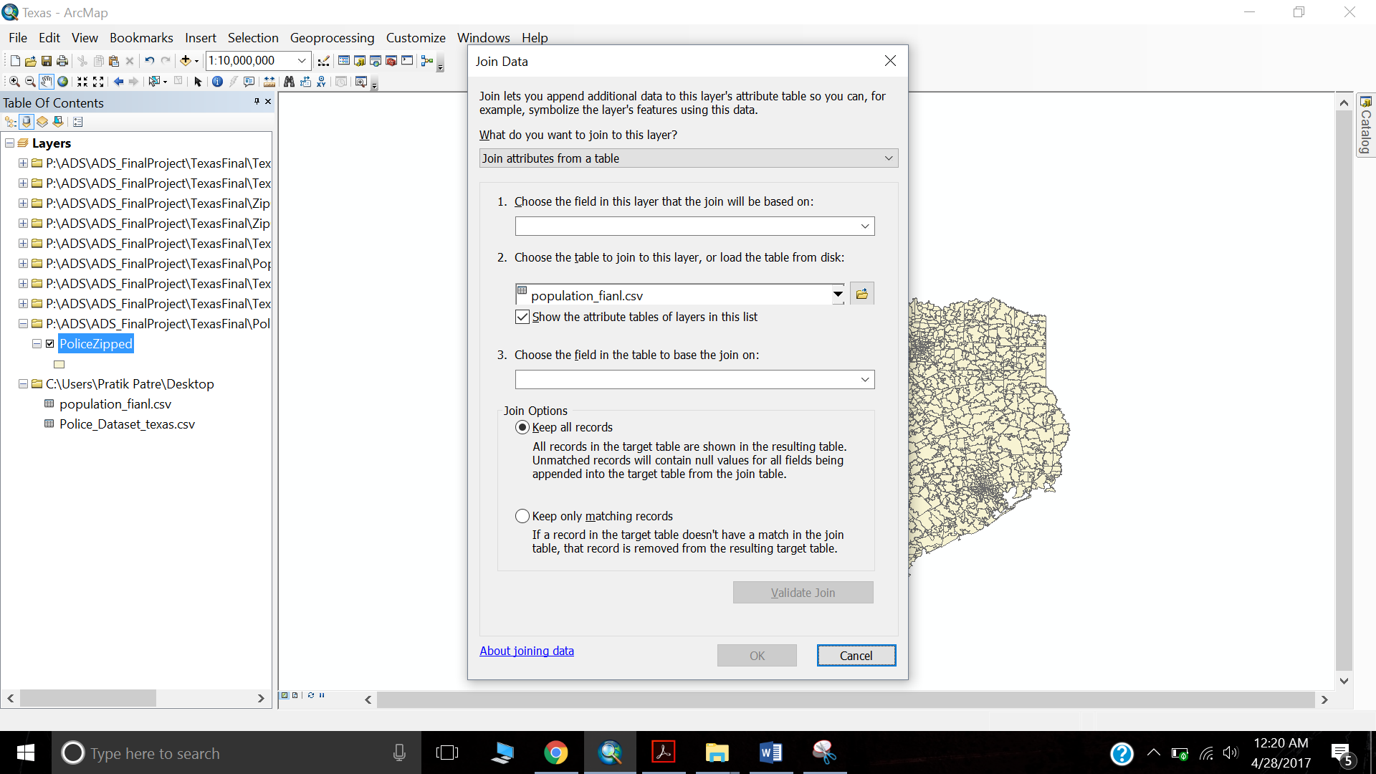

Now we select Police Station Data which is not equal to NULL. Thus we get 1053 records from 2690 records.

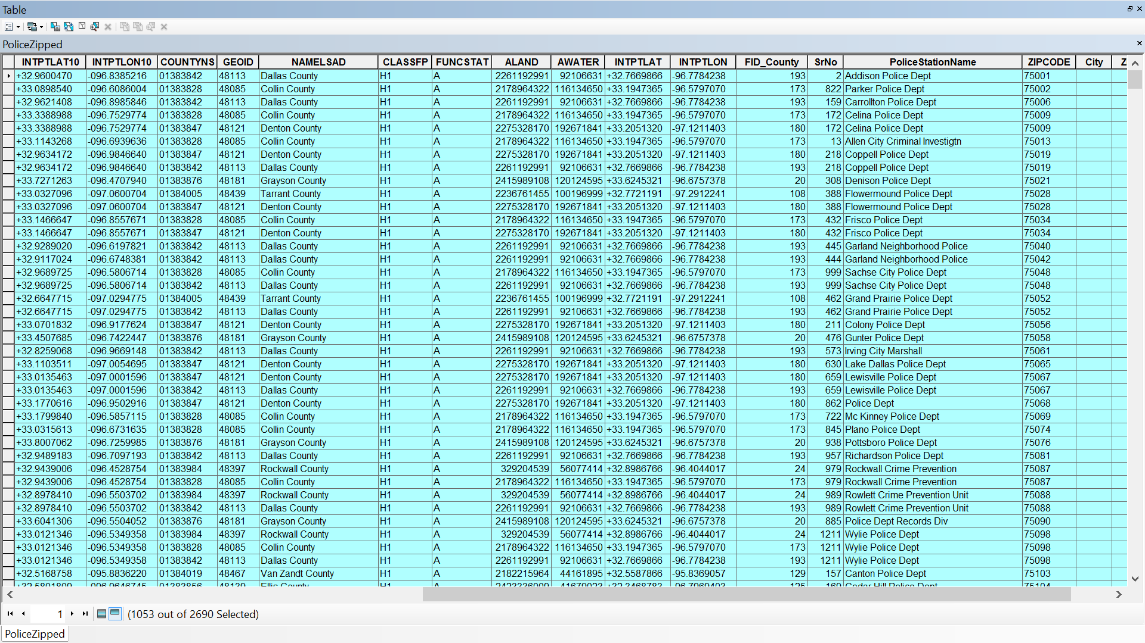

Step 12: Convert Selected Police Data to Police points by using Feature to Point functionality from ArcTool Box.

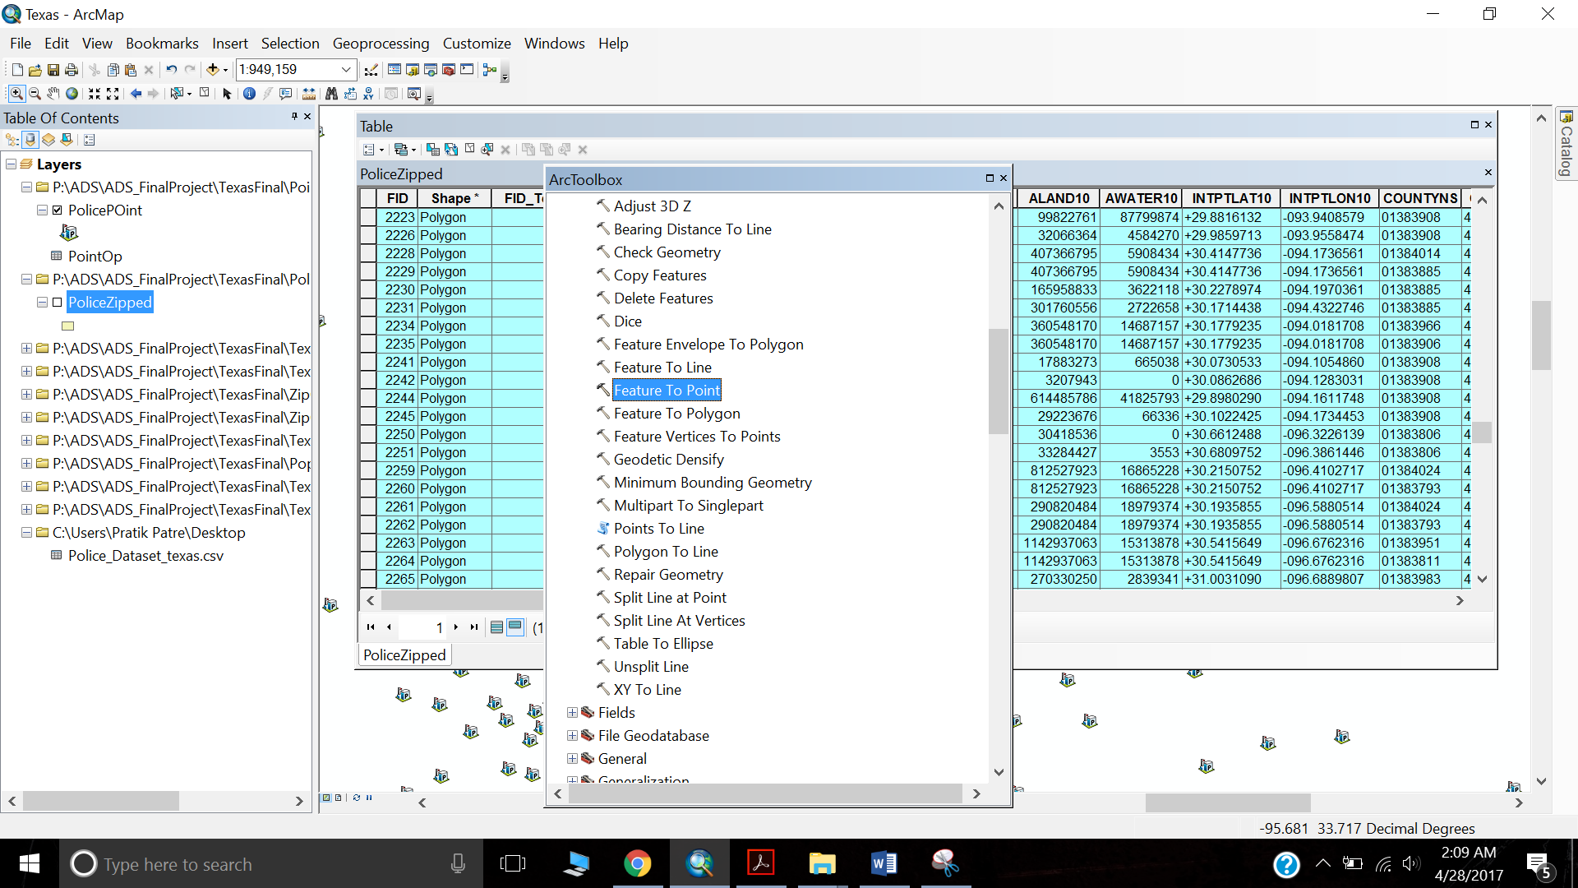

The input will PoliceZipped file which is the Police Data selected 1053 records.

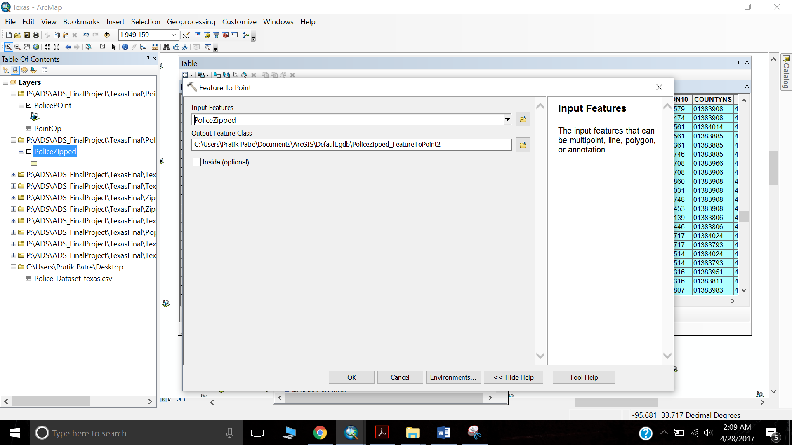

We further change the symbol from Symbol Selector.

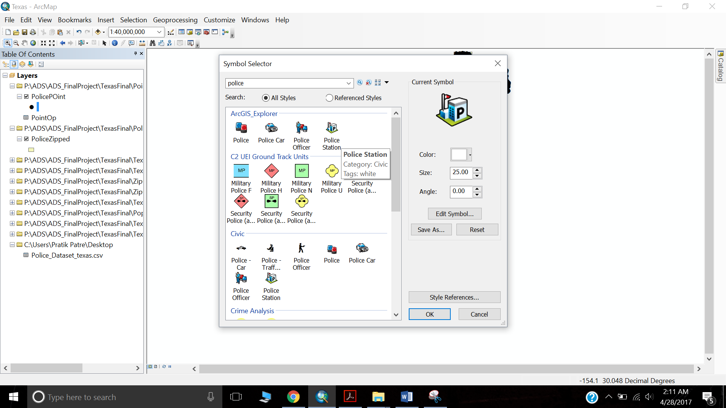

Finally, we have mapped our Police Point Data on Texas Data.

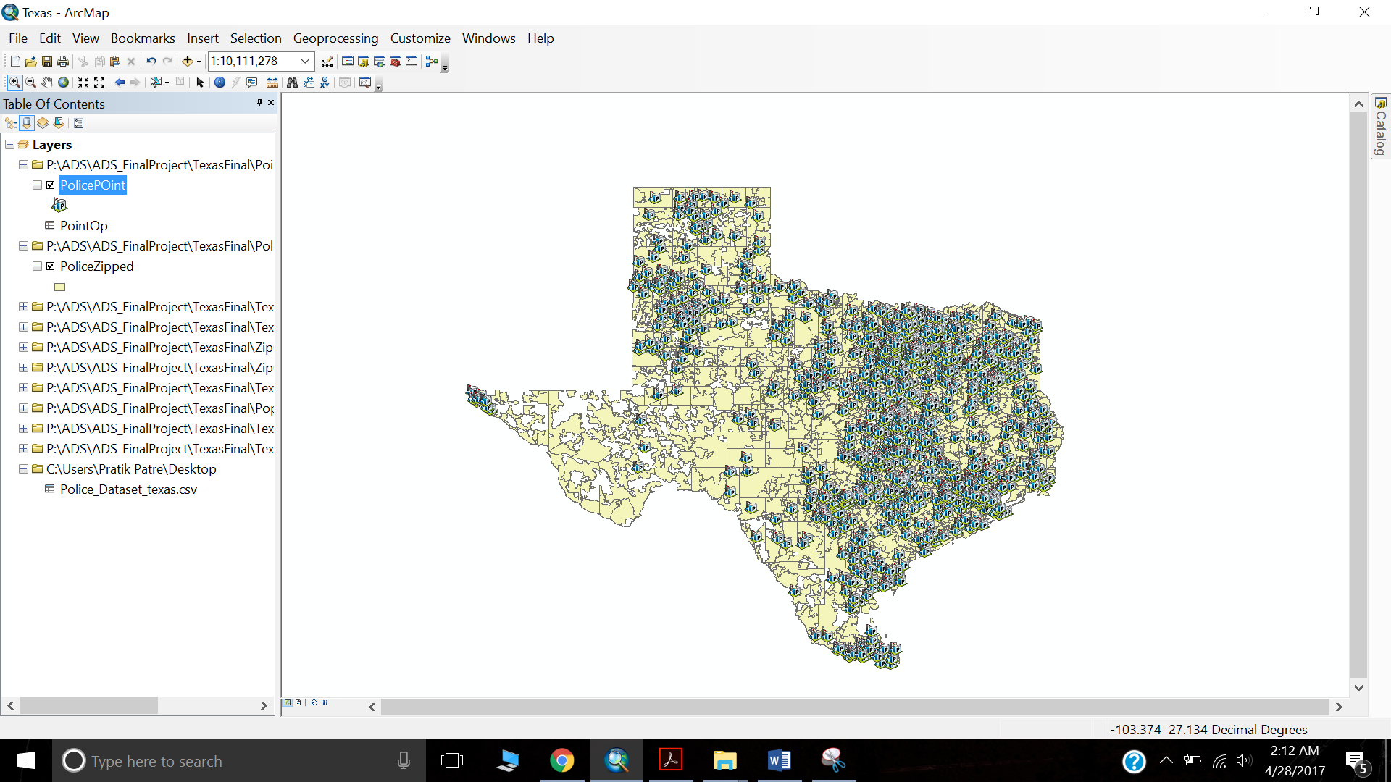

Step 13: Now we use spatial join from ArcTool Box to count the number of police stations in each of the zipcodes. The following image will be the output after getting the police count for each of the zipcodes of a county.

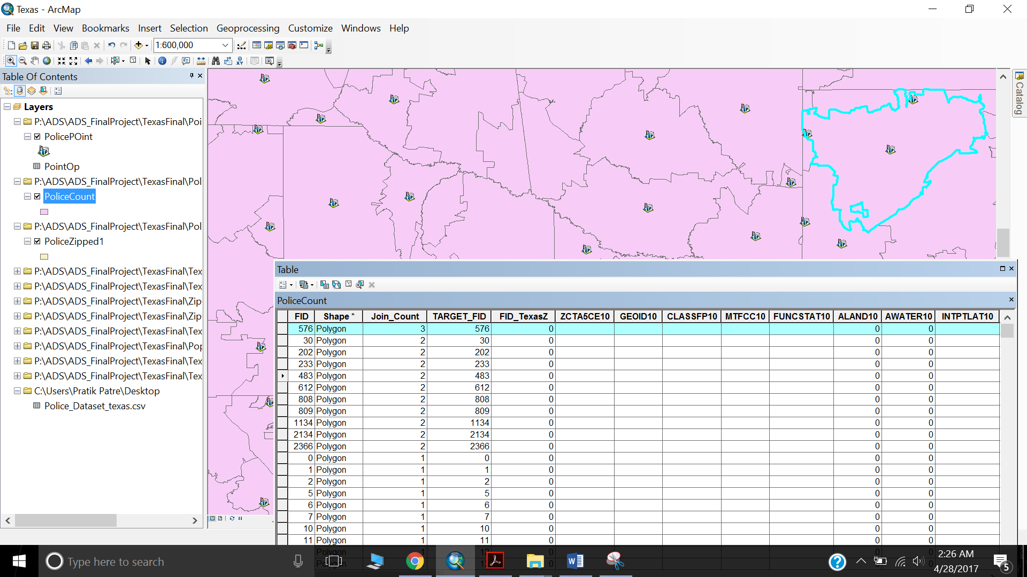

**Thus, we are done with analyzing police data and getting the count for each zip codes.**

Step 14: Next, we have to associate the population data with zip and county data. We use the same technique of intersect zip+county data with population data to get the population data merged with zip and counties. Next we find the density of population by calculating the density by formula, populationIndex/ area.

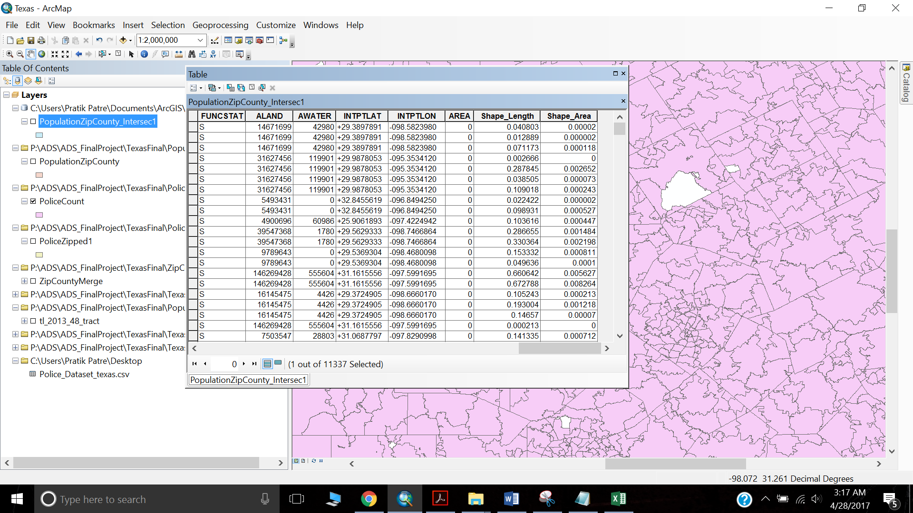

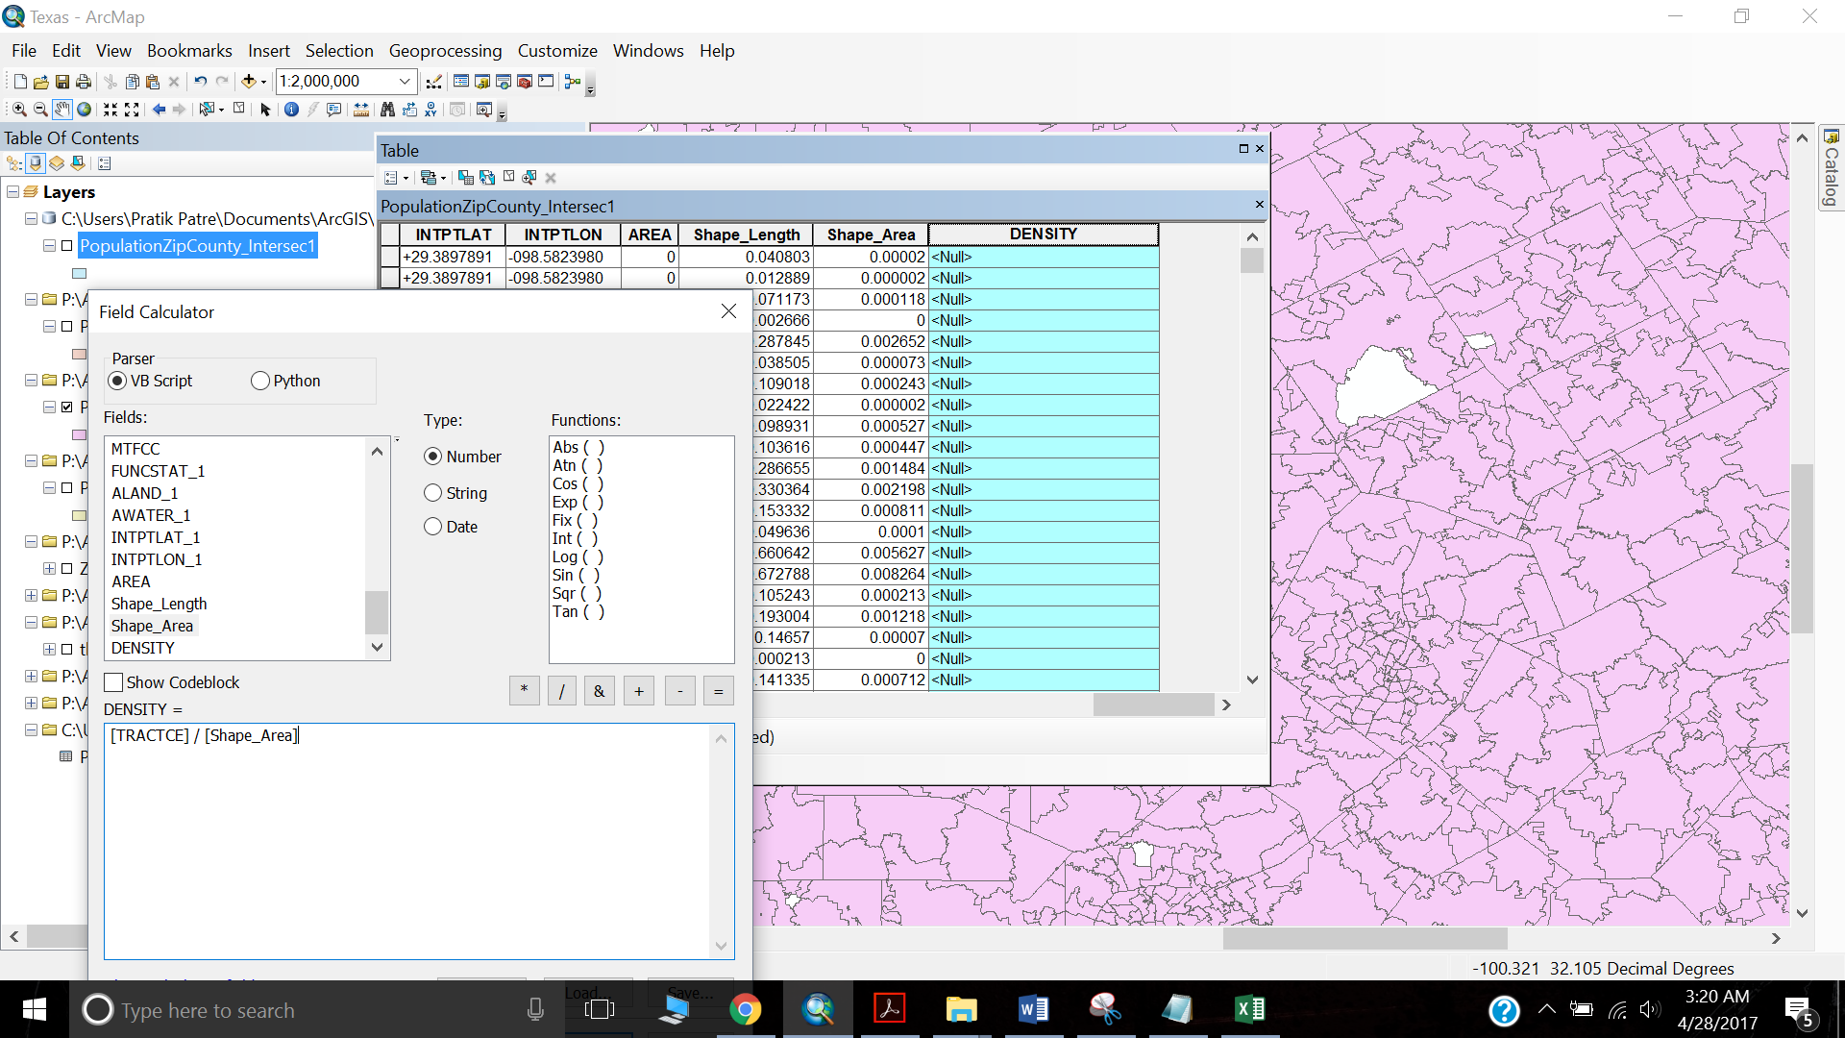

**Thus, we are done with population Data and getting the density for each of the zip codes.**

Step 15: Now, next step would be to work on the final data for geospatial analysis, TRAGEDY data. The Data was preprocessed in R and summarized for geospatial analysis.

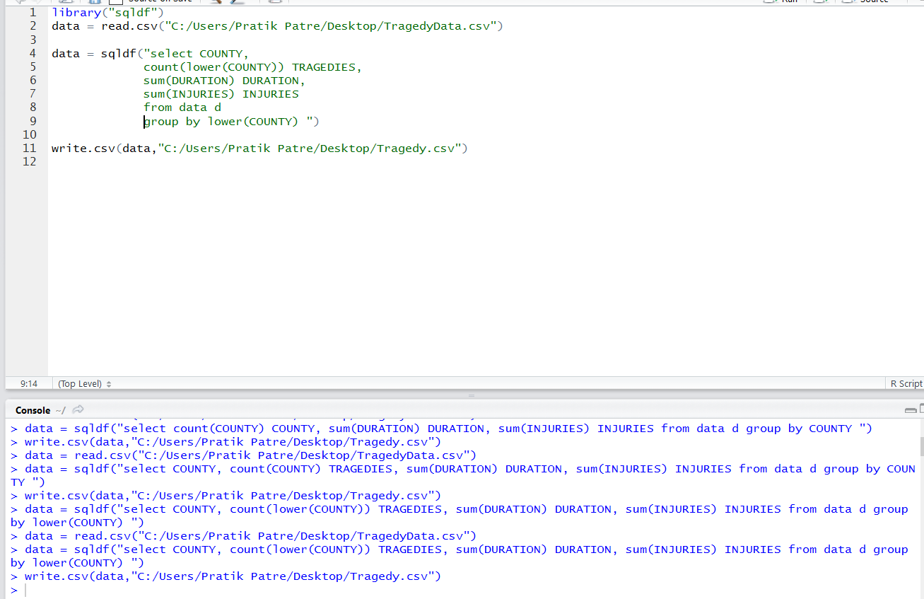

We use this CSV file in ArcMAP. We join this data with zip+county data to get the shape file so that we can map our tragedy data over the Texas map.

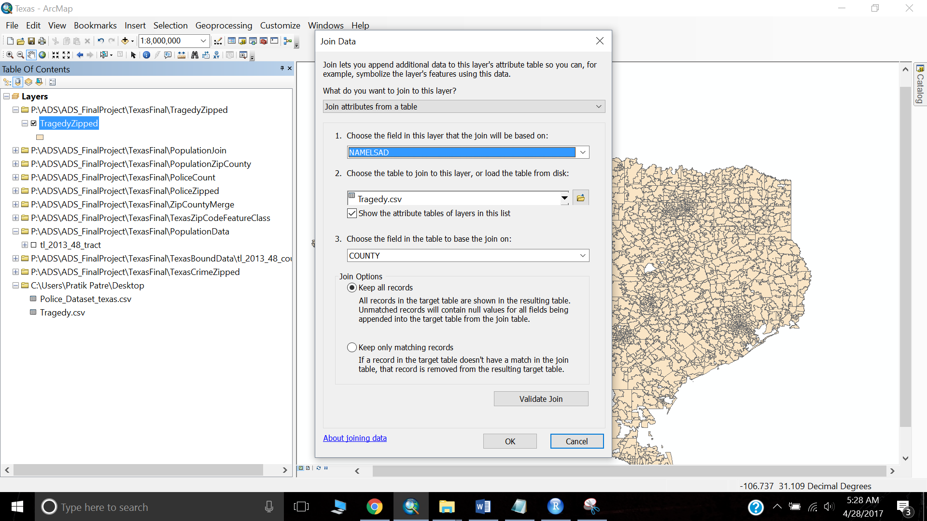

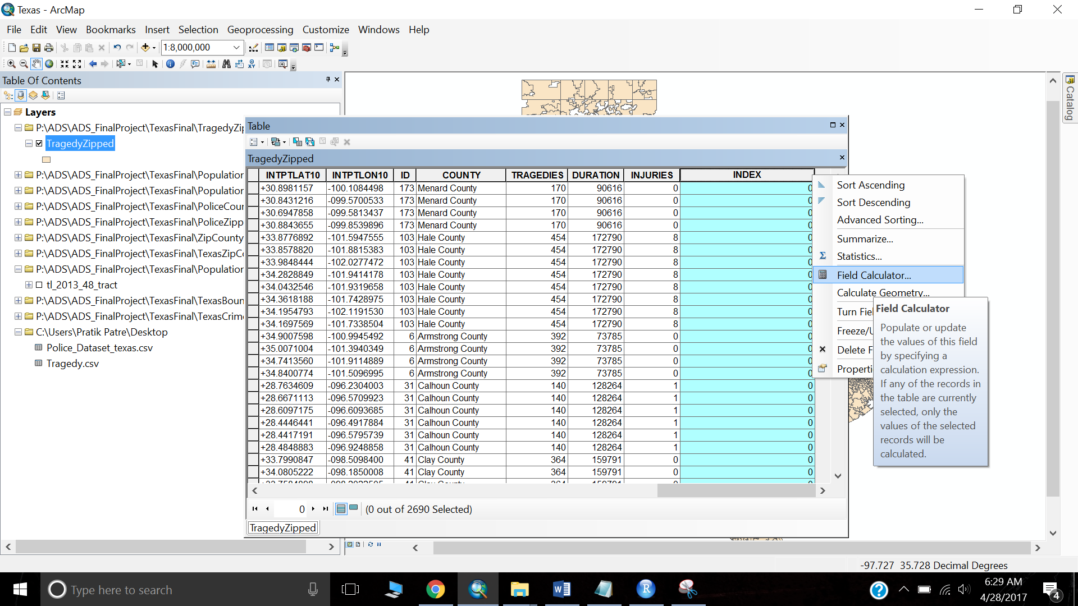

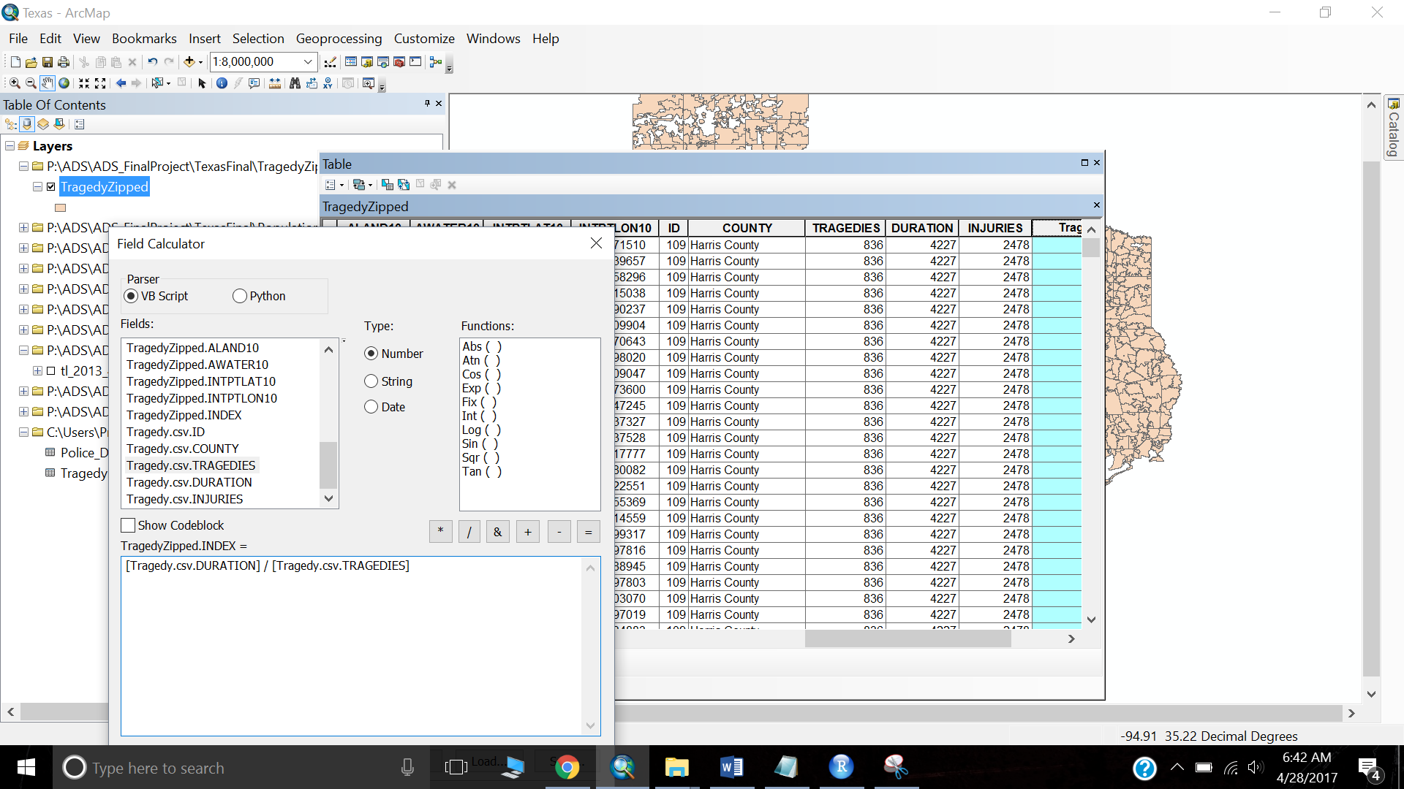

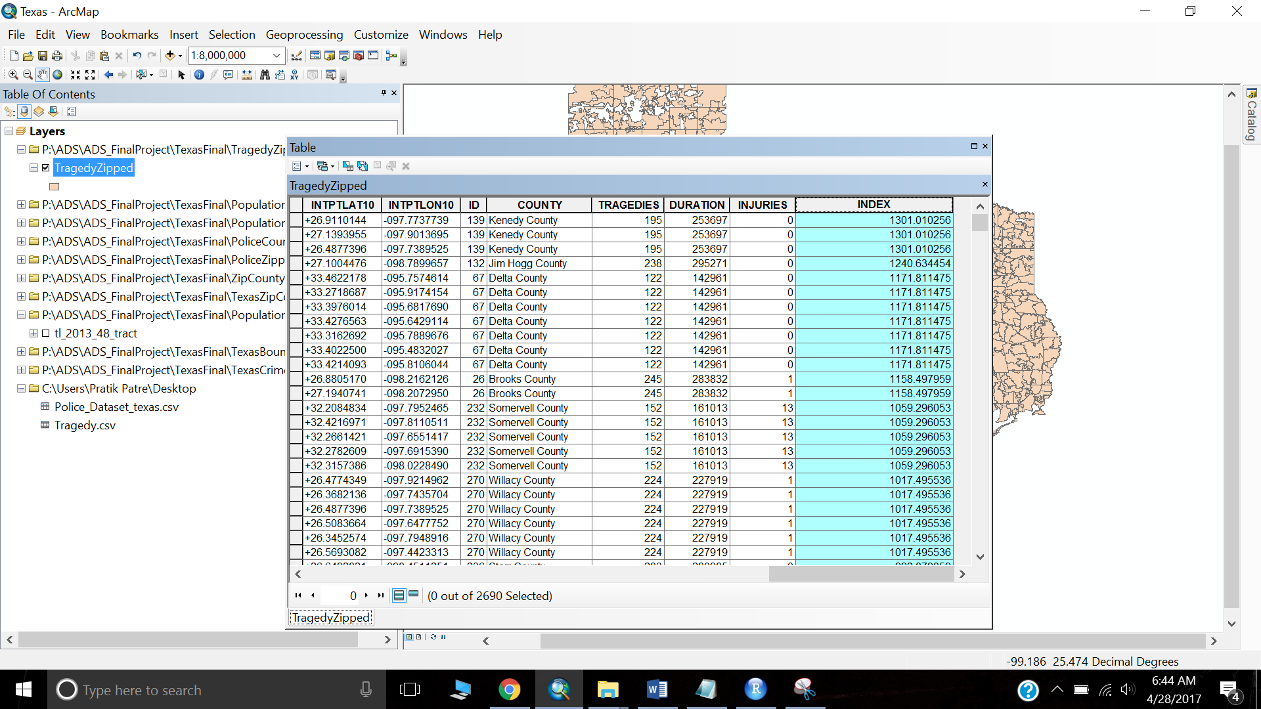`

Step 16: Now we perform Hot Spot Analysis on Police feature class which has the count of number of Police Stations in each zip code of a county. To do this we use the Hot Spot Analysis functionality in ArcTool Box.

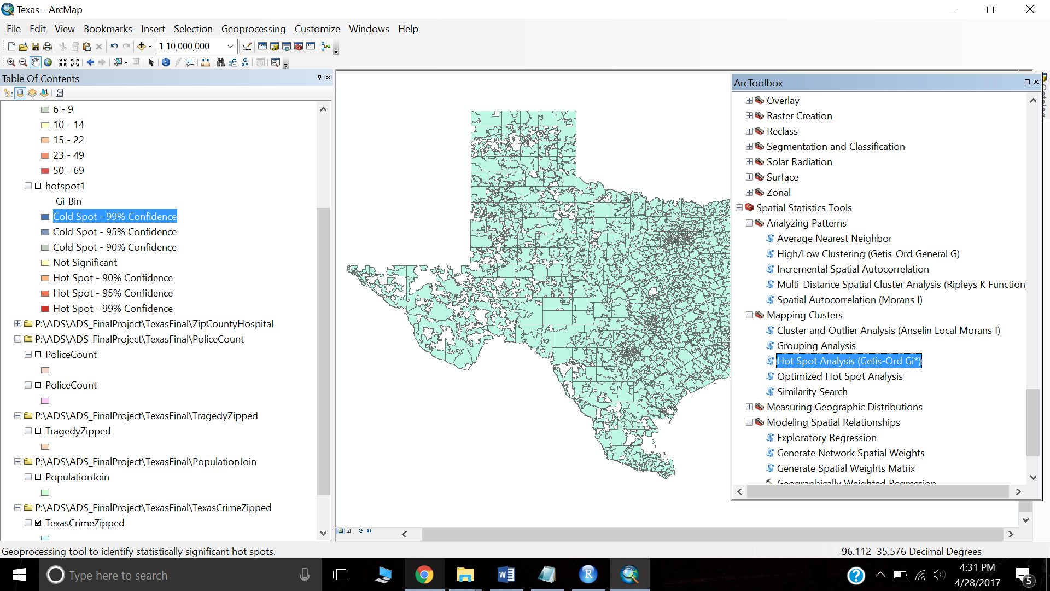

The input feature class will be Police Count Feature class which has the count as JOIN_COUNT.

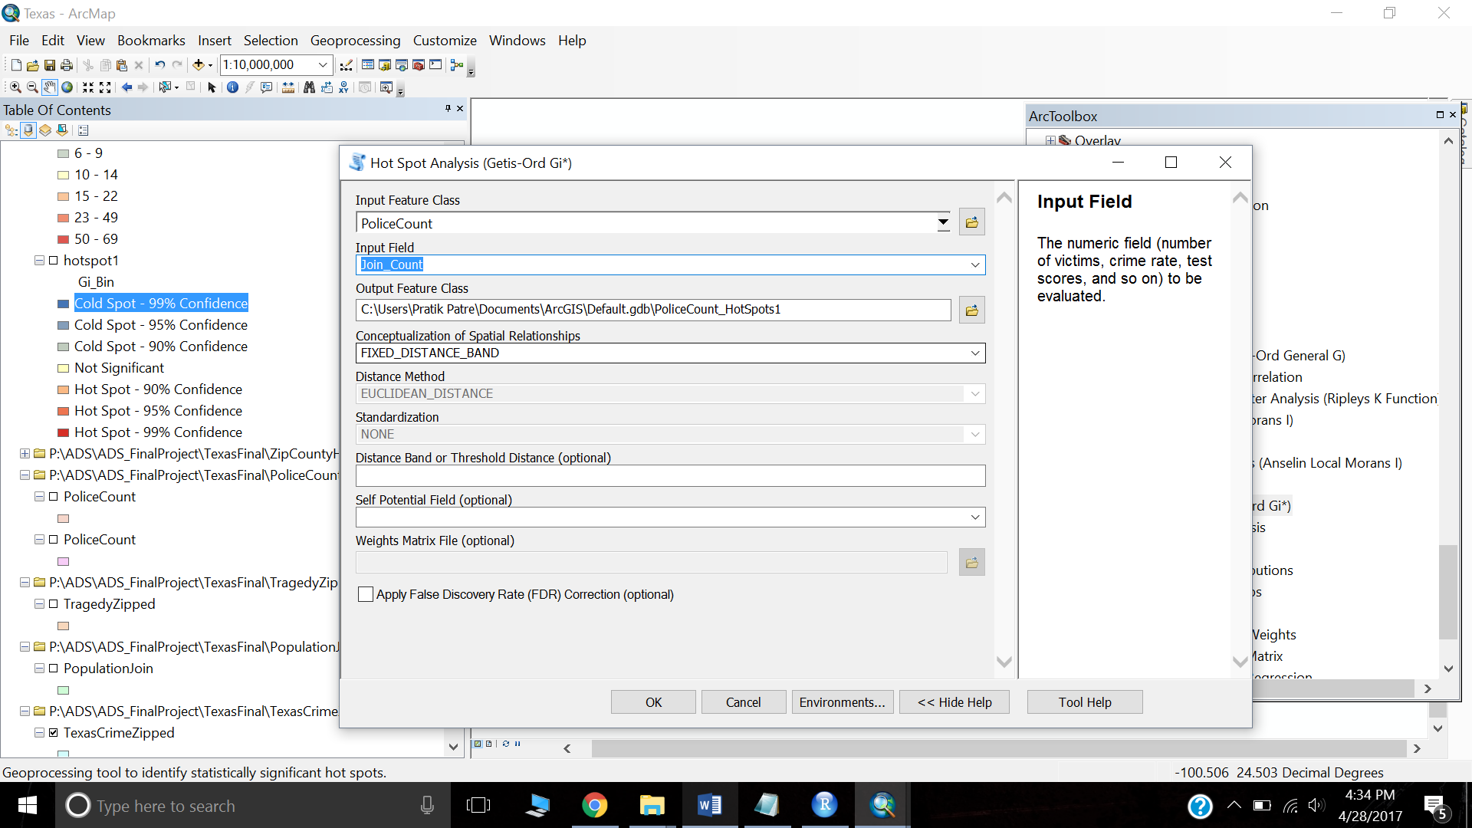

The below will be the output after hot spot analysis. It will give us cold spots and hot spots. The hot spots will show more number of police stations together and cold spots give us less number of police stations.

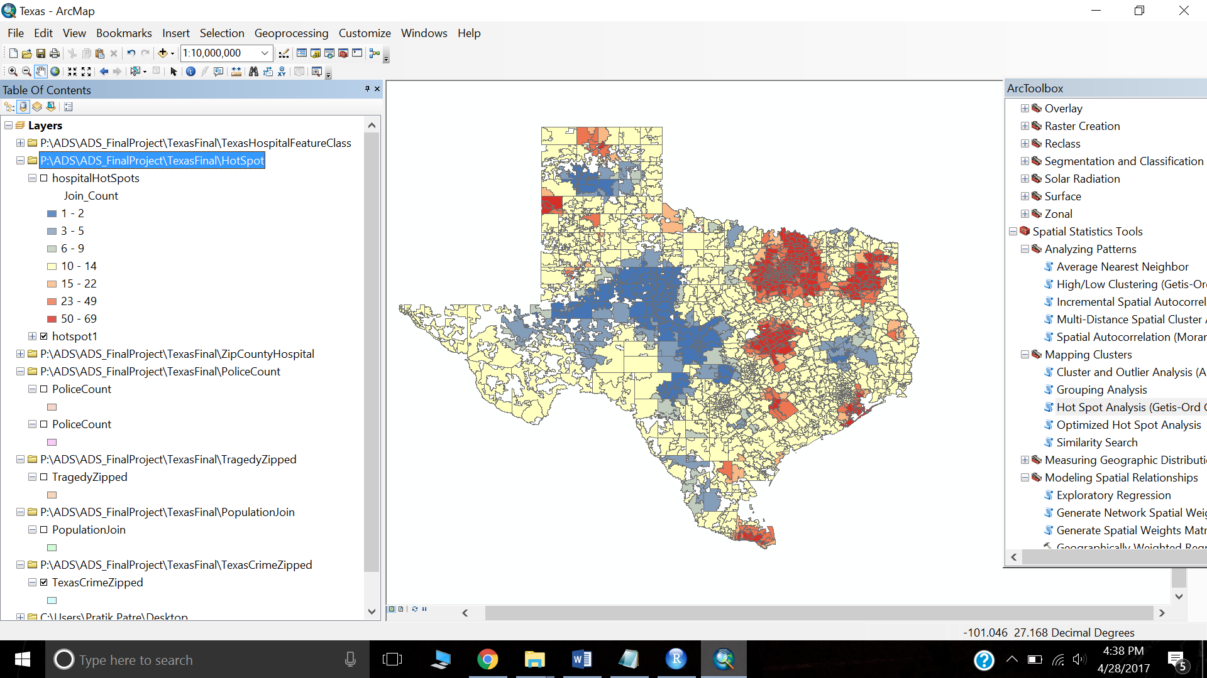

Step 17: We perform the same process for performing Optimized Hot Spot analysis. Optimized Hot Spot analysis will be used for point dataset. In our case, we have Hospital data as point dataset. The below will be the output after analysis.

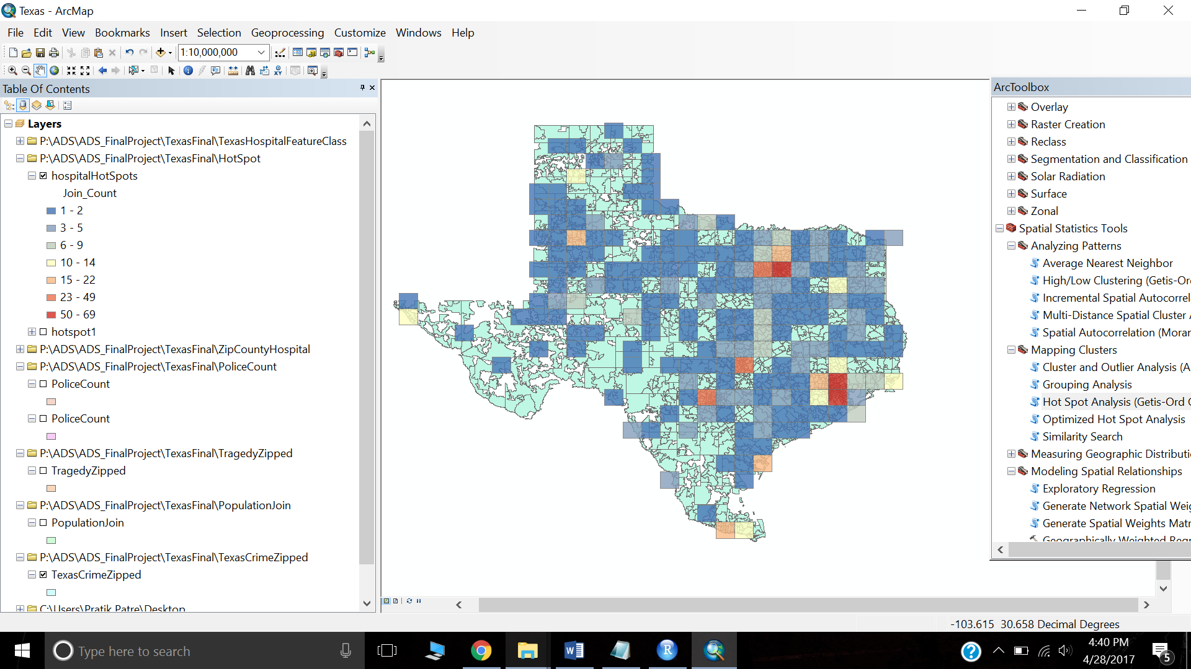

We can also perform a Weighted Regression. It shall predict the the price of property based on different spatial attributes. The weighted regression is provided in ArcTool Box under Modelling Spatial Relationships.

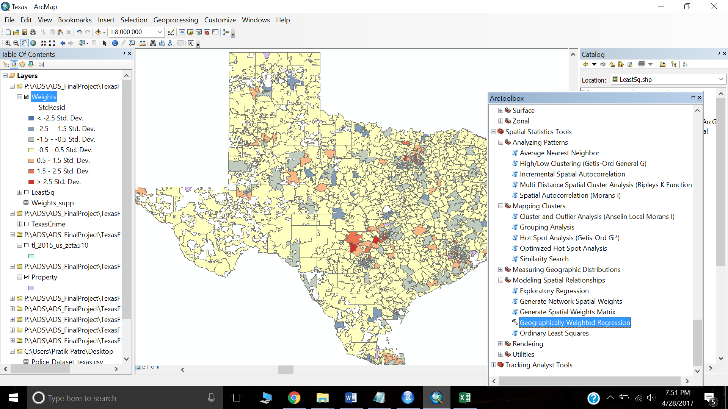

The Predictions came out as follow with R2 as 0.11

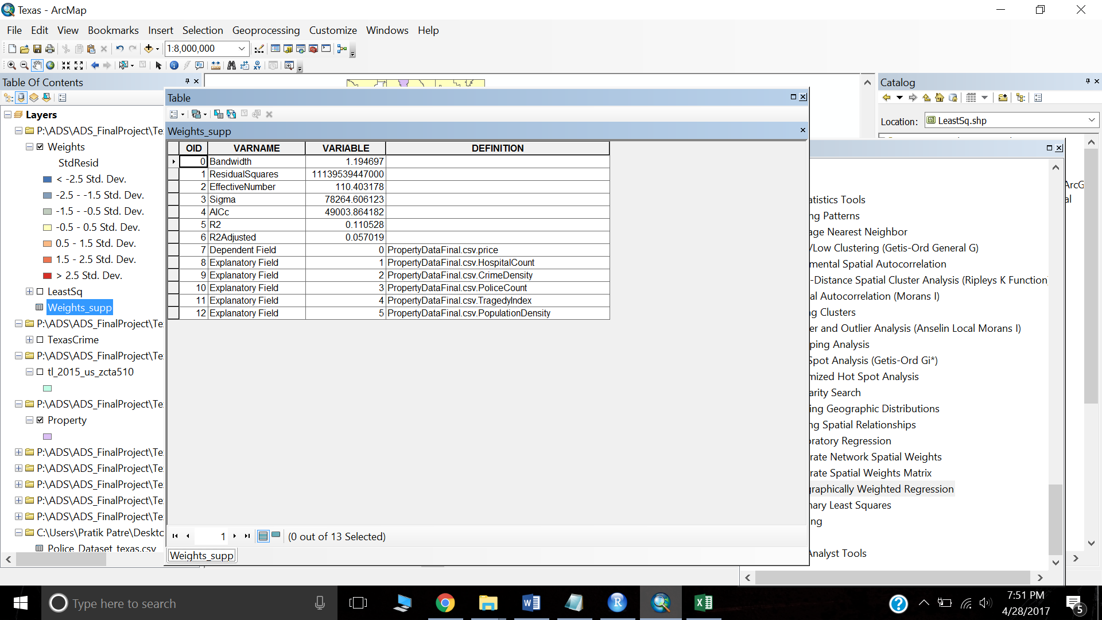

**Analysis on finding safer and populated area:**

We have performed Analysis on finding those areas which have high crime rate and high population. The Hot spot analysis gave us those hot spots which have lower crime rate and lower population. The below images gives a comparison of Texas Crime and HotSpot analysis.

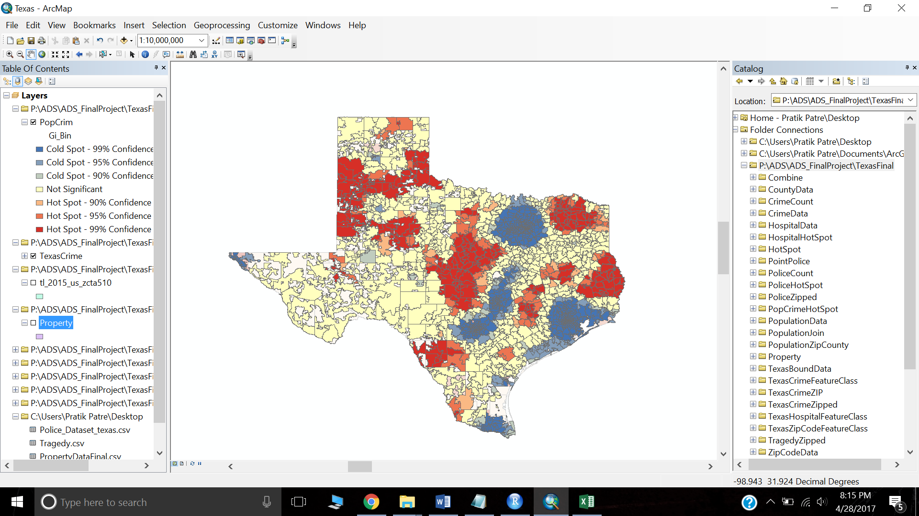 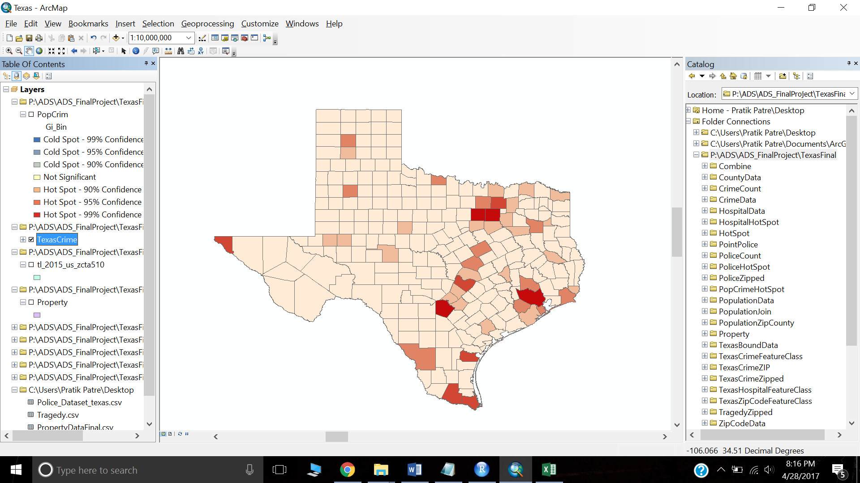

HotSpot Analysis for Population Data:

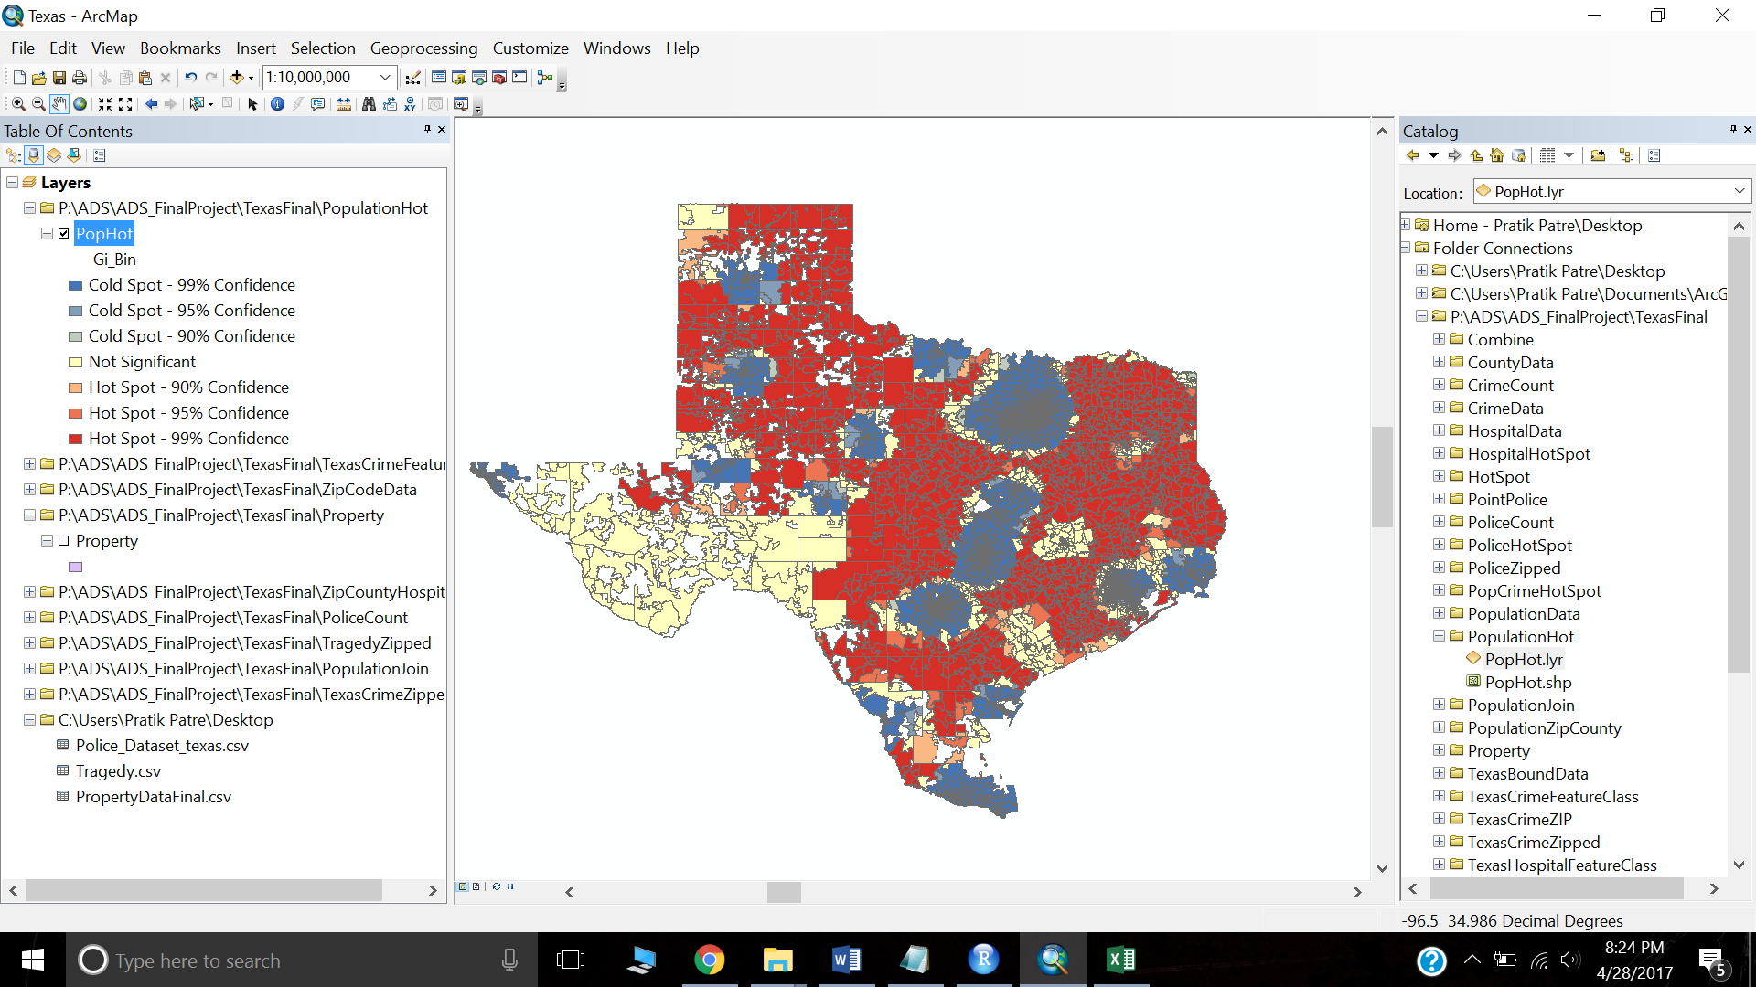

HotSpot Analysis for Tragedy Data:

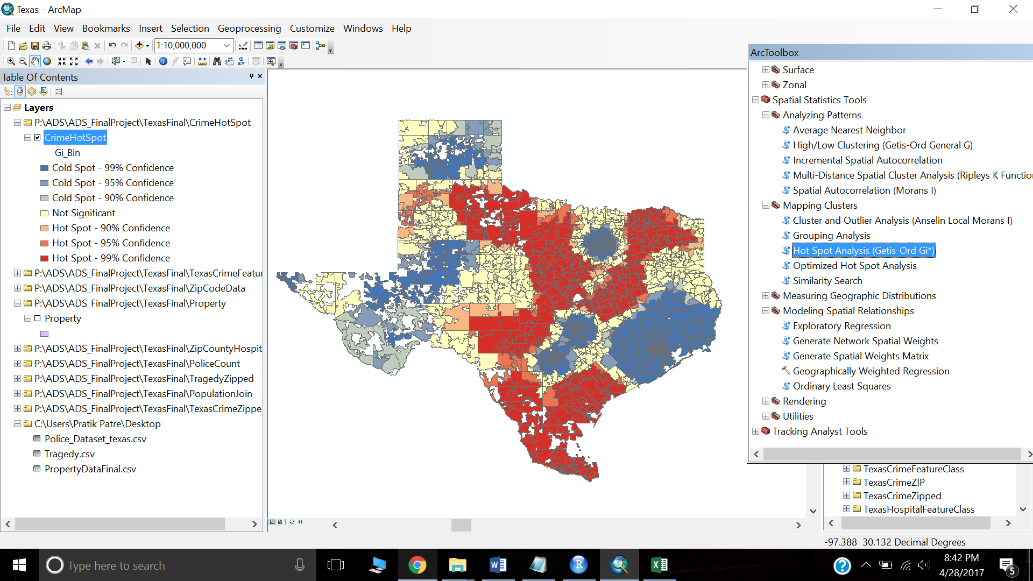

The shape files generated here can be published online with help of ArcGIS Online. Below are the steps to achieve this.

Save this as Layer file in the same location where the shape file is saved.

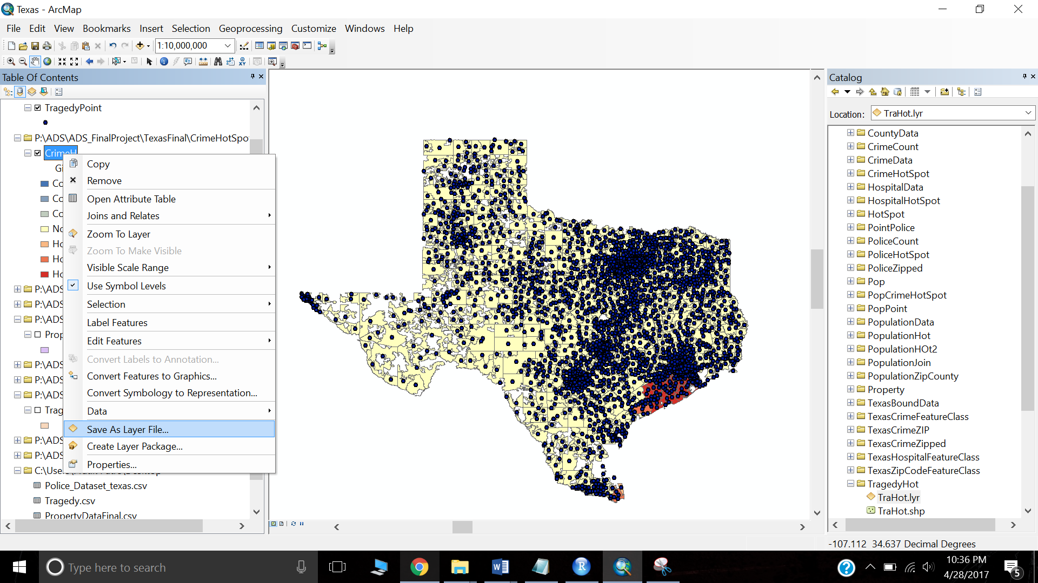

Further, compress the file as a zip file and login to ArcGIS Online.

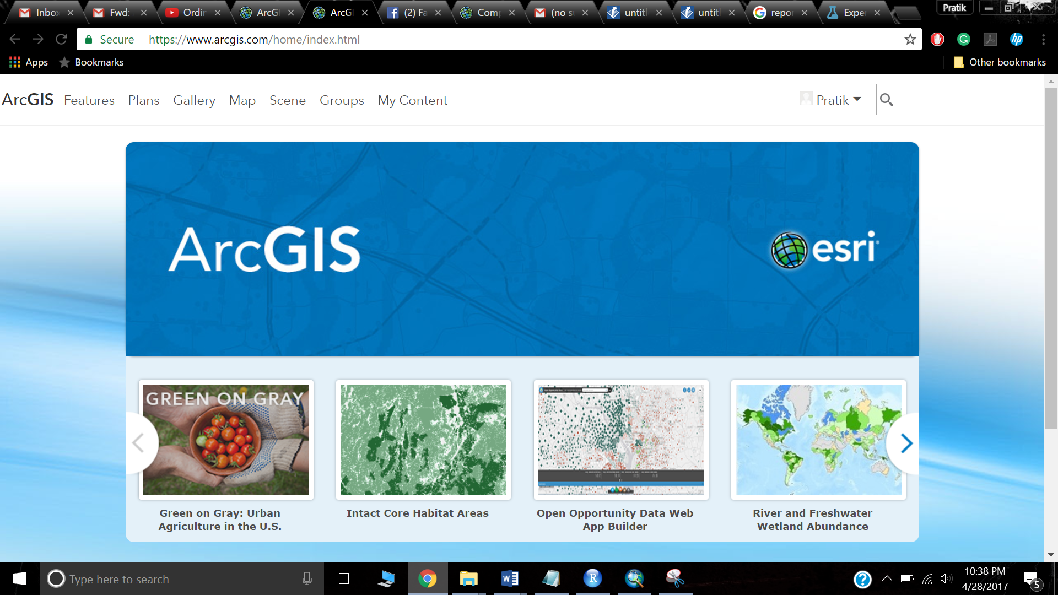

Go to map and add the compressed zip file by using add layer from file.

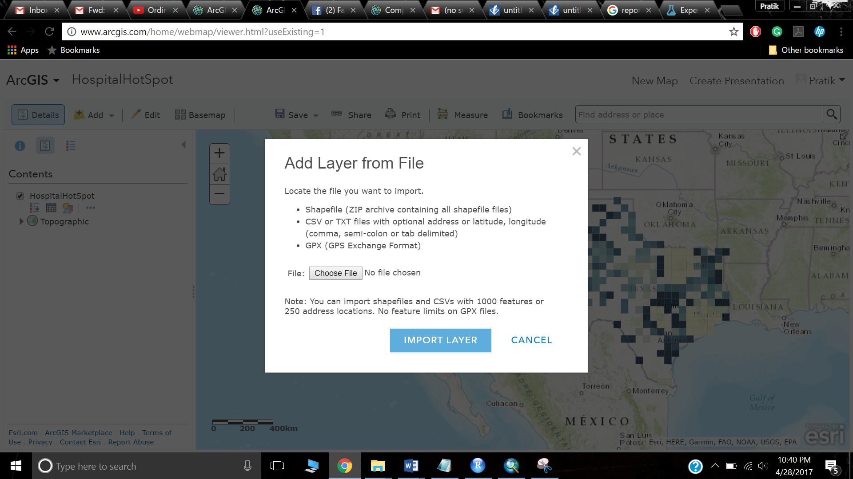

Once you are done adding file, the ArcGIS Online would look like this.

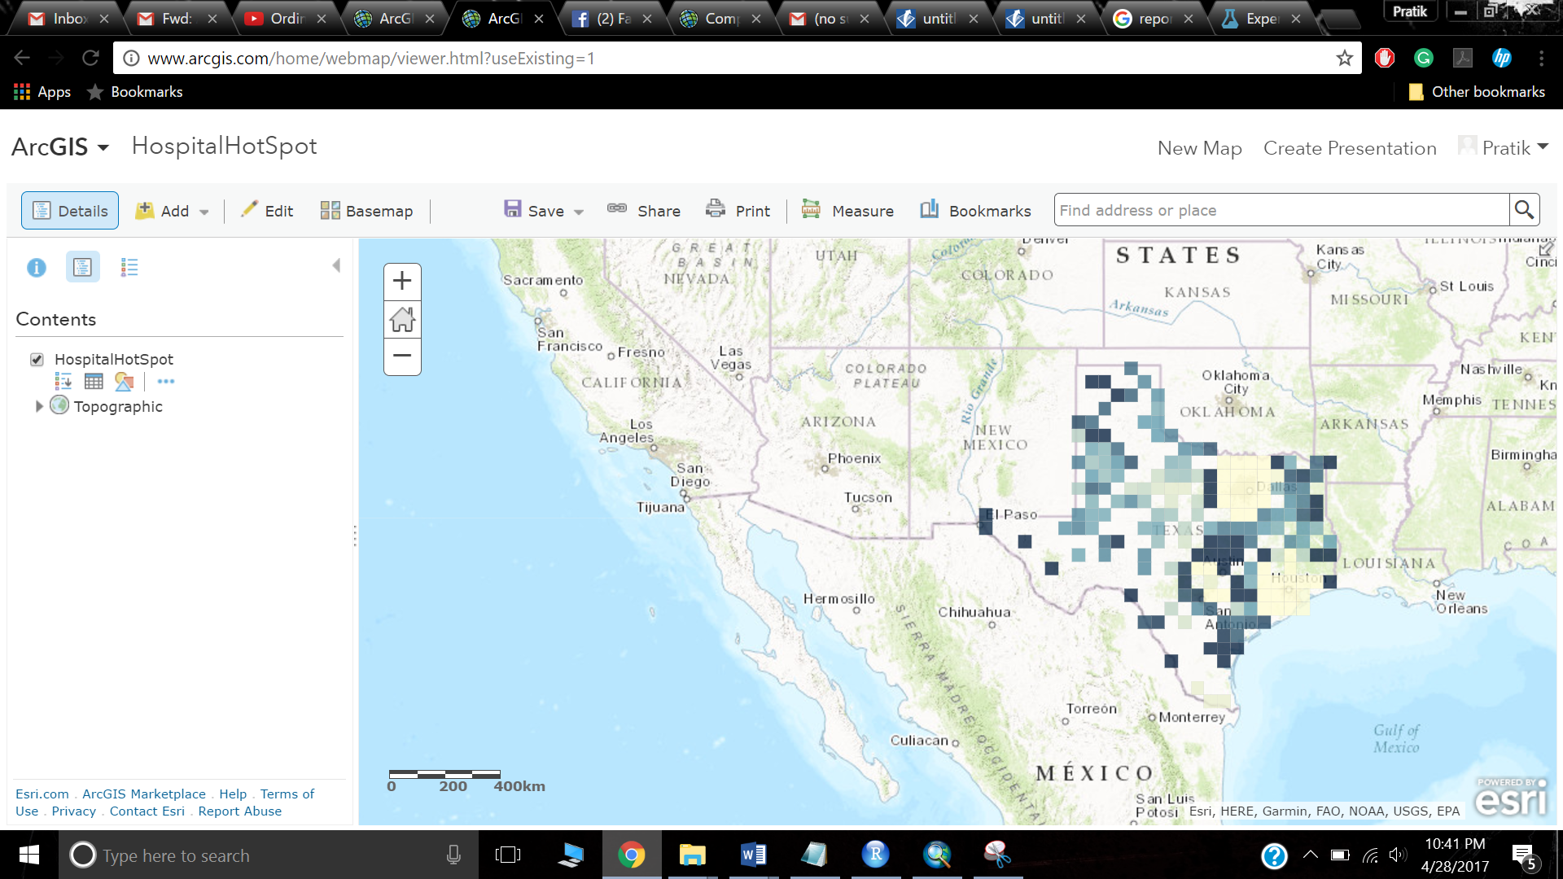

Next is to go to share button and create a new web app.

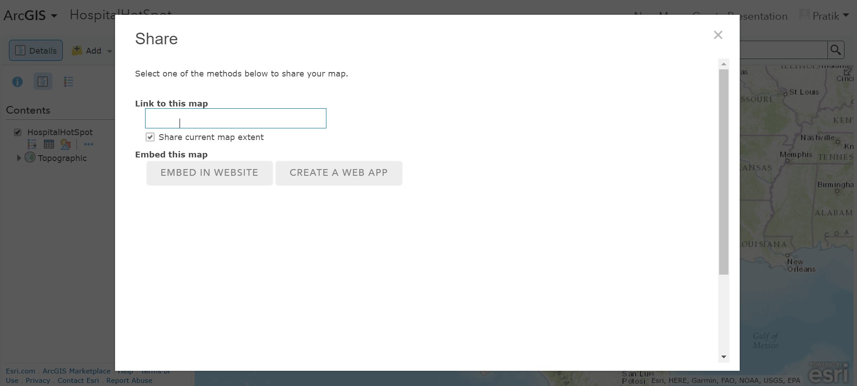

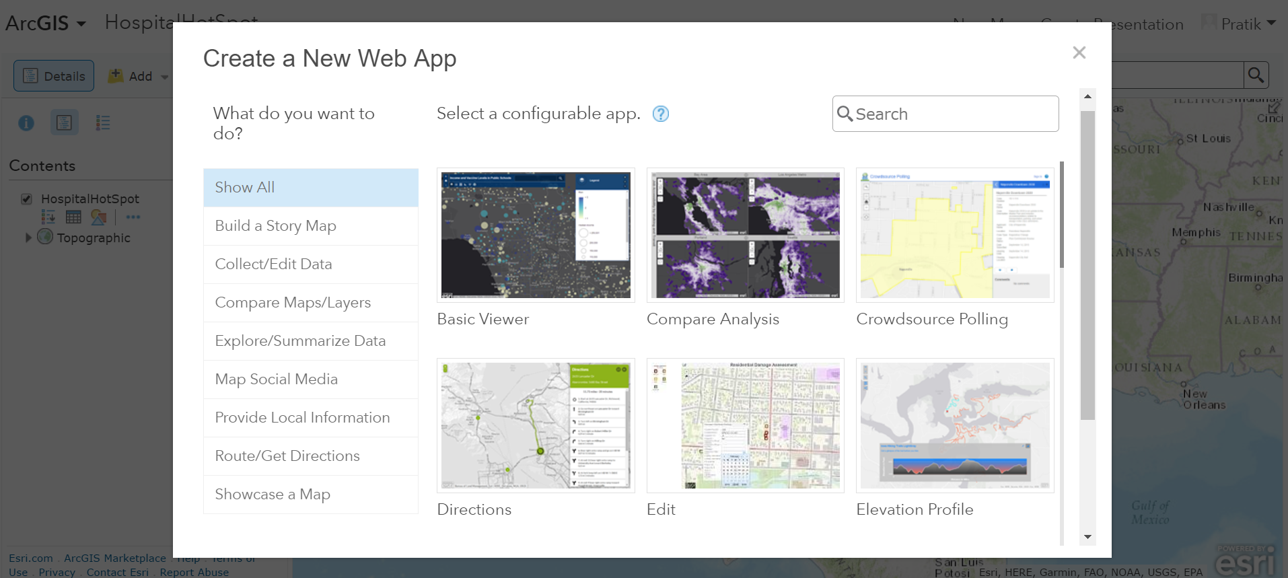

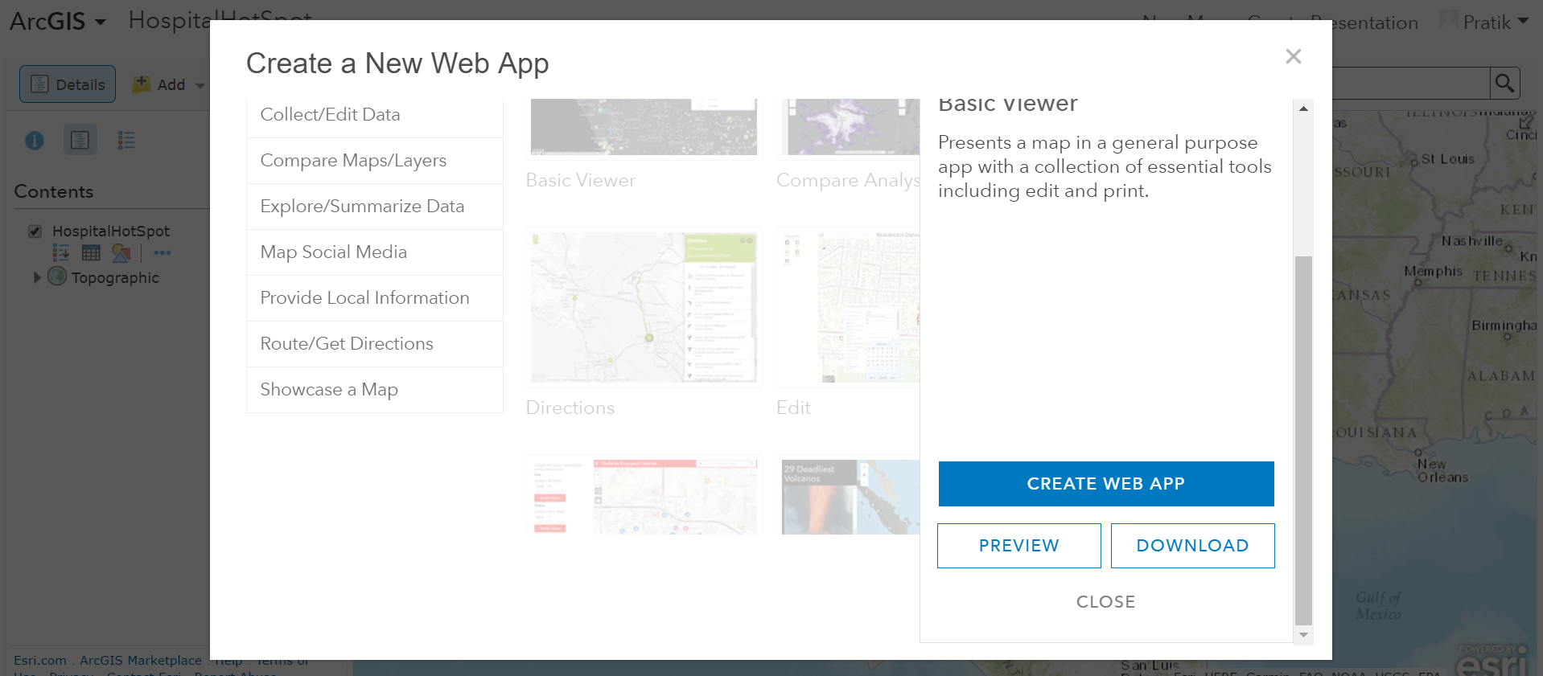

Finally, the map is published.

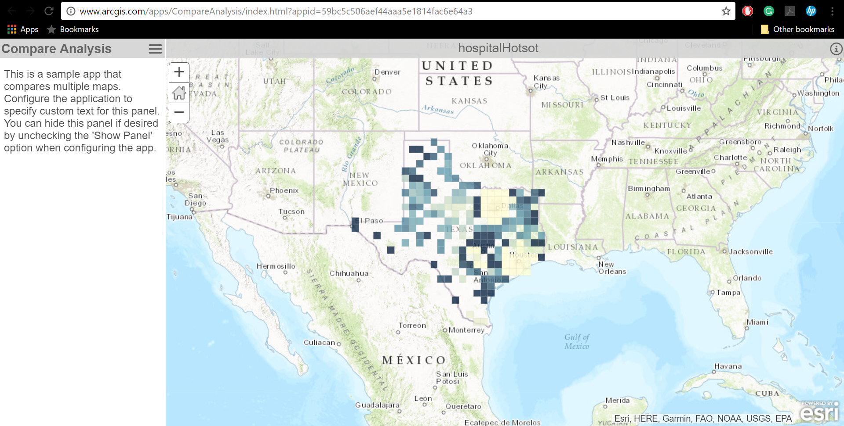

Model Runs:

The data from ArcMAP was retrieved after geospatial analysis. The following three prediction models were run for three use cases. Hence, there were a total of 9 model runs out of which random forest was chosen to be the best based on the R2 computation matrix.

1. Random Forest
2. Linear Regression
3. Neural Network

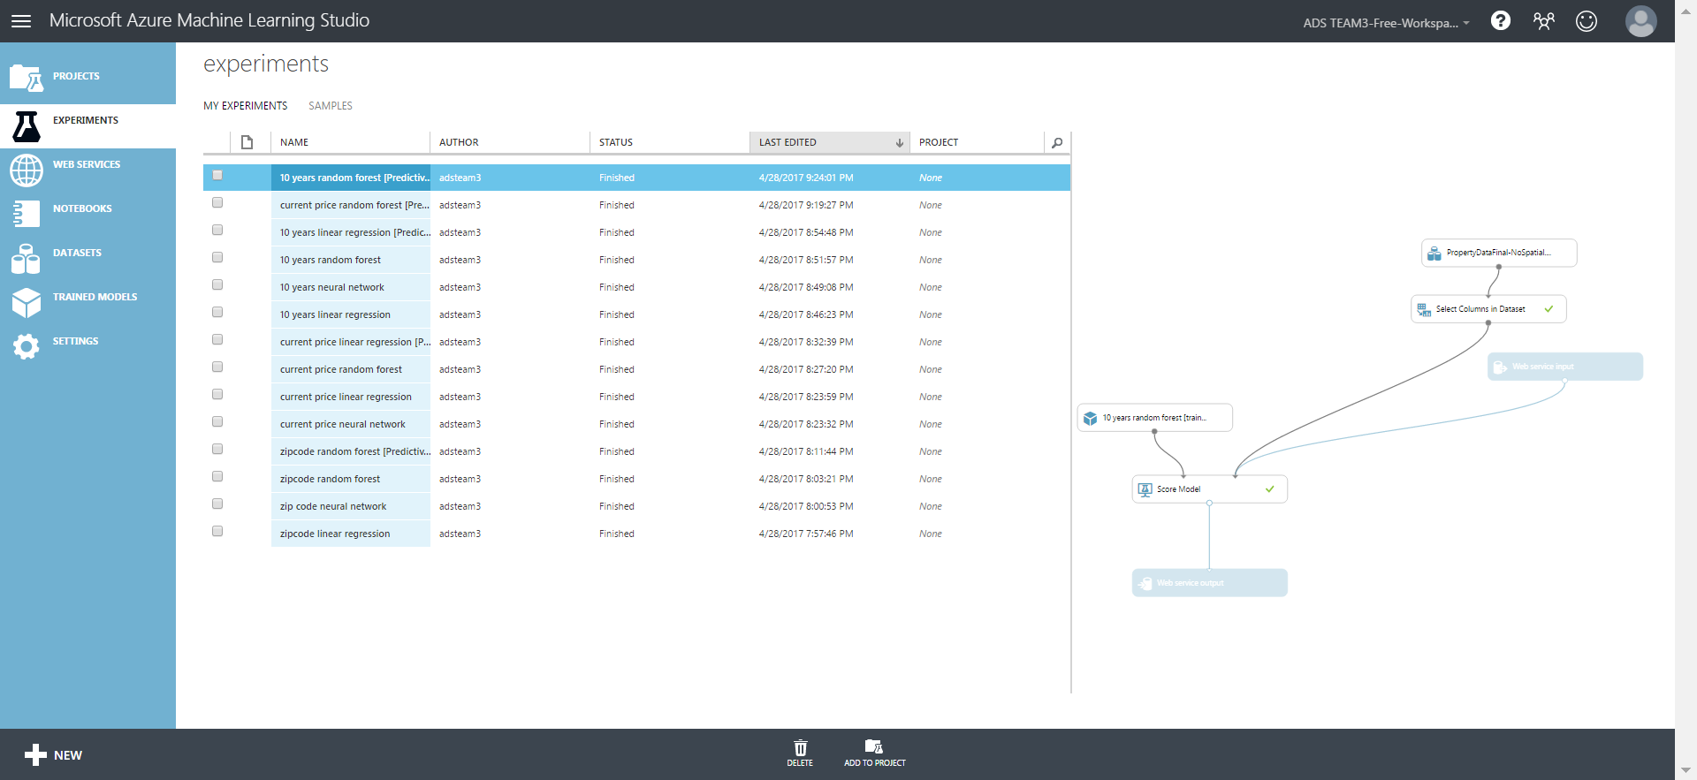

Random Forest:

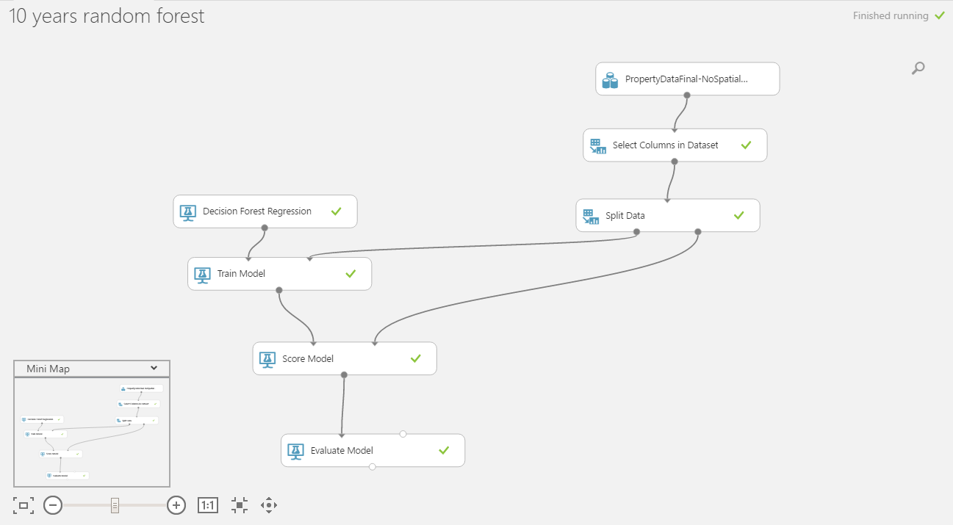

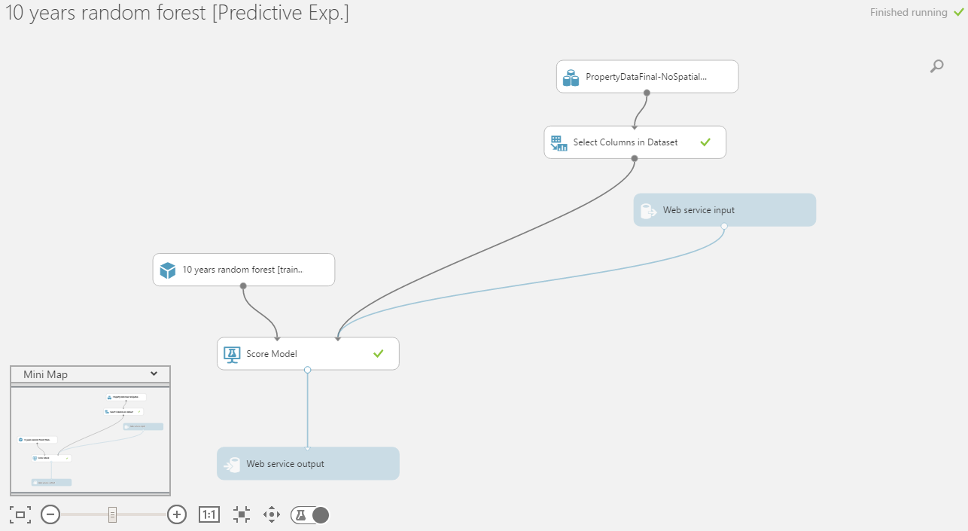

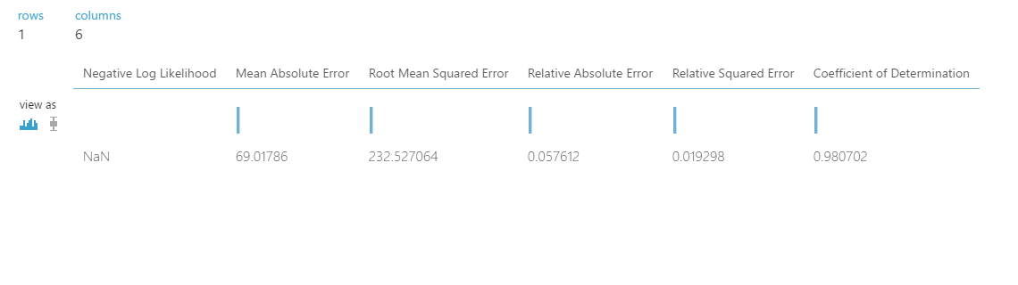

**UI:** <http://finalprojectads20170428113422.azurewebsites.net/>

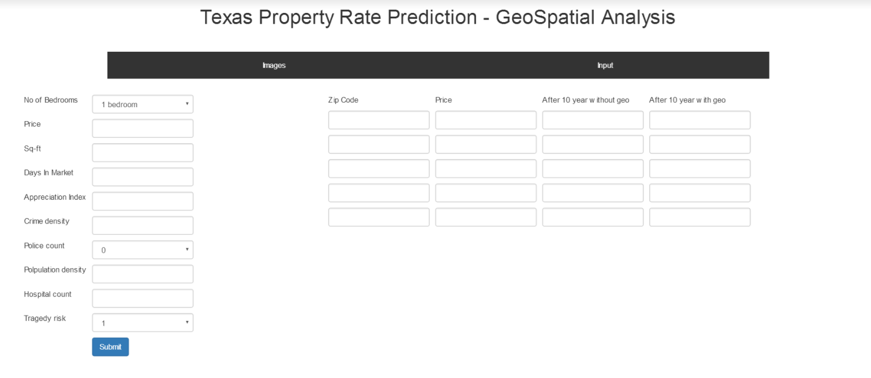

Asure ML login ID : [adsteam3@outlook.com](mailto:adsteam3@outlook.com)

Password : Rahul@123